Hi

**Getting involved**

The cancellation of the London Marathon, and countless other fund raising events, is leaving a massive hole in the revenue of charities at a time when they need it most.

Stuart has sent the attaching information regarding an alternative event – the 2.6 Challenge.  Give it go and let us know what you are going to do!

<https://www.twopointsixchallenge.co.uk/>

**Furloughed Employee Communication**

We wanted to let you know that we have created a furlough resources page on the AAT website which has been set up to provide a way to share resources with our furloughed colleagues and to keep everyone up to date and included in what’s going on at AAT. The webpage includes:

* BC team updates/competitions!
* Communication Cascades
* Some of the intranet resources covering wellbeing and kids resources
* Furlough information and any updates along with the process for reviewing the furlough arrangements
* Links to discounts and vouchers
* How to Access Payslips

The webpage is accessible via this link <https://www.aathornton.com/furlough-resources/> (and is not visible externally). Please note the content is being finalised this morning ready for a link to be sent to furloughed colleagues later today but feel free to browse if you wish to. The webpage will be kept up to date and will be available alongside other regular line management/team communication. If you have any suggestions for additional content please let Jill/Karen know.

**Community support from Vince**

Vince has been making constructive use of his spare timefixing 3D printers and 3D printing parts for PPE equipment.   Vince says:

“Here is a look at the parts I am contributing, each shield take approximately 2 hour 30 mins to print at this quality and uses 3.4 meters (28 grams) of PLA filament . There are 3 versions of the shield currently being used and this is the RC1 shield.

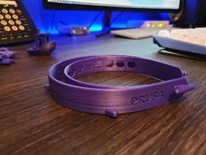

And what they look like assembled:

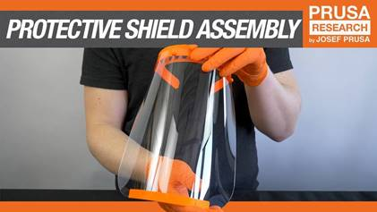

I am now printing the RC3 headband specifically for the Essex area providing Southend & Basildon Hospitals. The RC3 band is the one at the front and uses the same amount of PLA with roughly the same print time as the previous band. The red is the supplied Kit from the group that is printing for Essex including high quality red pla and a specific extruder nozel that we are required to use.”

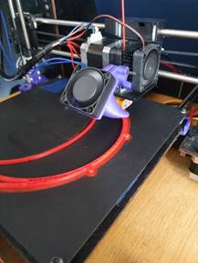

That is amazing Vince – well done!

**Competition time & Gill Household**

We have been making significantly less constructive use of our time at home than Vince - focussing on this 1000 piece “impossible” minion jigsaw.

–

We then invested further time creating this time lapse video:

<https://youtu.be/CqKyN3Zba-M>

This leads to the competition this week.  For the usual £25, how many days did it take us to complete this epic waste of time?  I am looking for the number of days that it took to finish the jigsaw – ignore the time for the video.

This week there is a second prize - the jigsaw (as we never want to see it again and need to get rid of it).

Some of you may know that my own self-isolating started before the lockdown and hence get quite close to the answer (assuming I started this as soon as the self-isolation started, which I might have – or might not).  Anyway, as a tie-breaker, please also guess how many wine gums I ate when I visited the office last Friday – the answer is somewhere between 0 and 40.

Guesses by 10am on Monday please.

Have a good weekend.

**BC Contacts**

* + - Karen Genuardi    07801 523186
    - Ian Gill                   07782 248216
    - Vince Bixby           07725 900367
    - Claire Pitman        07956 862824
    - Craig Turner          07946 629052
    - Adrian Bennett      07817 894781
    - Alok Suthar           07877 350839

The BC Team

|  |  |
| --- | --- |
| Ian Gill Partner, Patent & Trade Mark Attorney | |
| **DL:** +44 (0) 20 7440 6841 **E:** [isg@aathornton.com](mailto:isg@aathornton.com)  **W:** [aathornton.com](http://www.aathornton.com/) | [Linkedin](https://www.linkedin.com/company/aathornton)[Twitter](https://twitter.com/AAThorntonCo) |

|  |  |
| --- | --- |
| AA Thornton & CO | **A.A. Thornton & Co.** 10 Old Bailey London, EC4M 7NG T +44 (0) 20 7405 4044 F +44 (0) 20 7405 3580 |
| COVID-19 - At AA Thornton we are well equipped to proceed with business as usual, and to provide uninterrupted, high-quality service to our clients. Please click [here](http://www.aathornton.com/covid-19/) for our latest update. | |

