Hi

**Furlough leave Q&A**

The Q&A document relating to furlough leave has been updated in response to the government’s decision to extend the scheme to the end of June.  The impact of this extension on our implementation of the scheme is addressed in the first question in the updated Q&A document, which is attached.



**IT**

Your PC needs a restart occasionally to pick up security and other updates, but please do select restart not shut down!

**Competition time & Gill Household**

Well done to Nikesh who was spot on with his guess of 30 days.  Geoff was not far behind with 26 days and gets second place and the damn jigsaw.  The wine gum issue was moot but, for the record, I ate 32.  (I know, I know but the office is mothballed so I can’t even make myself a tea or coffee when I am in.)  Many of you seem to think that it would have taken around a week and Dan was as bold as to guess 5 hours 36 minutes.  Dan, if you want to give that a go then ask Geoff to borrow the puzzle!  If you can complete the edge in that time I’d be impressed.

To avoid jigsaw withdrawal issues we have now moved to this 2000 piece “monster” jigsaw but I suspect that will be a lot easier than the minion puzzle.

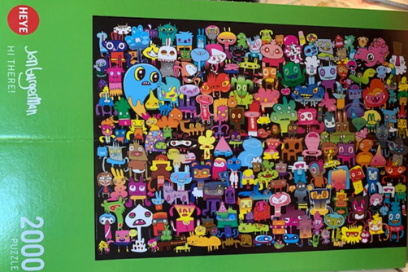

**BC Contacts**

* + - Karen Genuardi    07801 523186
    - Ian Gill                   07782 248216
    - Vince Bixby           07725 900367
    - Claire Pitman        07956 862824
    - Craig Turner          07946 629052
    - Adrian Bennett      07817 894781
    - Alok Suthar           07877 350839

The BC Team

|  |  |
| --- | --- |
| Ian Gill Partner, Patent & Trade Mark Attorney | |
| **DL:** +44 (0) 20 7440 6841 **E:** [isg@aathornton.com](mailto:isg@aathornton.com)  **W:** [aathornton.com](http://www.aathornton.com/) | [Linkedin](https://www.linkedin.com/company/aathornton)[Twitter](https://twitter.com/AAThorntonCo) |

|  |  |
| --- | --- |
| AA Thornton & CO | **A.A. Thornton & Co.** 10 Old Bailey London, EC4M 7NG T +44 (0) 20 7405 4044 F +44 (0) 20 7405 3580 |
| COVID-19 - At AA Thornton we are well equipped to proceed with business as usual, and to provide uninterrupted, high-quality service to our clients. Please click [here](http://www.aathornton.com/covid-19/) for our latest update. | |

