Hi

We hope you had a good weekend.

**New SurveyMonkey reminder**

Please complete the survey as soon as possible and if possible, by Wednesday 29 April.

Here is the link: <https://www.surveymonkey.co.uk/r/VGZKHKY>

**Gill Household**

I have now got back to my pre-virus weight with a lot of help from wine gums. I was pondering how to stop my wine gum habit turning into a gateway sweet when I came across these hints on the BBC News website on how to stop snacking in lockdown.

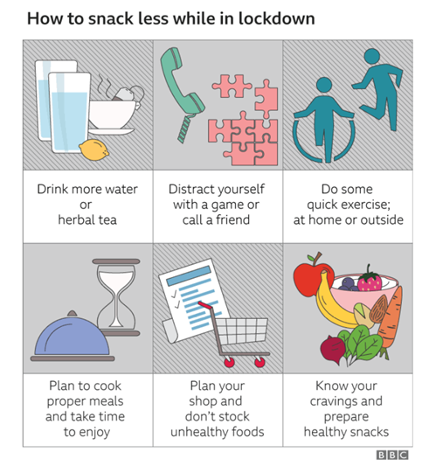

Here is the full article which I read whilst finishing off my supply of unbelievably delicious “tangy” wine gums.  I won’t be buying any more.

<https://www.bbc.co.uk/news/stories-52329529>

**Competition time**

And the winner is Lindsey!  Well done.  Attached is the answer!

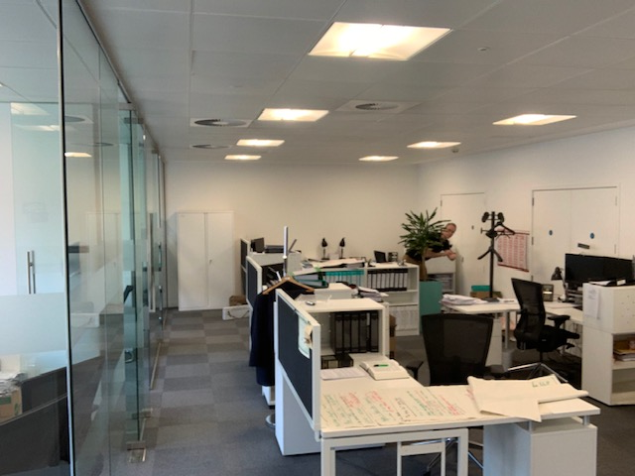

**BC Contacts**

* + - Karen Genuardi    07801 523186
    - Ian Gill                   07782 248216
    - Vince Bixby           07725 900367
    - Claire Pitman        07956 862824
    - Craig Turner          07946 629052
    - Adrian Bennett      07817 894781
    - Alok Suthar           07877 350839

The BC Team

|  |  |
| --- | --- |
| Ian Gill Partner, Patent & Trade Mark Attorney | |
| **DL:** +44 (0) 20 7440 6841 **E:** [isg@aathornton.com](mailto:isg@aathornton.com)  **W:** [aathornton.com](http://www.aathornton.com/) | [Linkedin](https://www.linkedin.com/company/aathornton)[Twitter](https://twitter.com/AAThorntonCo) |

|  |  |
| --- | --- |
| AA Thornton & CO | **A.A. Thornton & Co.** 10 Old Bailey London, EC4M 7NG T +44 (0) 20 7405 4044 F +44 (0) 20 7405 3580 |
| COVID-19 - At AA Thornton we are well equipped to proceed with business as usual, and to provide uninterrupted, high-quality service to our clients. Please click [here](http://www.aathornton.com/covid-19/) for our latest update. | |

