Hi

Wellness

Claire came across a great article that seems to ring true with quite a few of us about why we might feel tired on lockdown – there is a link below.

http://theconversation.com/here-is-why-you-might-be-feeling-tired-while-on-lockdown-135502

Online security

Please stay alert for phishing and other scam emails. Opening links or attachments in emails remains the most likely way that that our systems will be infected and presents a significant security risk. If an email appears to be work related but you are not certain that it is legitimate please forward it to support@aathornton.com before opening any links or attachments. If an email is not work related it should be deleted.

Exam success

Well done to Michael who has passed his “Querying Data with Transact-SQL” Microsoft exam with an impressive score of 700 out of 840.

To Michael I say:

SELECT
success,
satisfaction
FROM AAT.dbo.FURTHER_QUALIFICATION

Oystercard refunds
Oystercard refund requests relating to coronavirus can now be submitted online, rather than calling, holding hours and then being cut off before you speak to anyone (not that I’m bitter). The online process is quick and easy.

https://tfl.gov.uk/fares/refunds-and-replacements/coronavirus

Competition time

We are back to “Spot the Ian” for the competition this week. You should know the rules from last time and another £25 is on offer. Please mark the photo with a cross where you think I am standing/sitting/crouching/suspended in the second photo and return your guess by 10am on Tuesday. I noticed a number of people last time thought I would be standing right in the middle at the front. But will I do that this time? Or won’t I? Perhaps I will stand at the back right like last time? I am beginning to confuse myself! Please just put a cross somewhere and send back the photo. 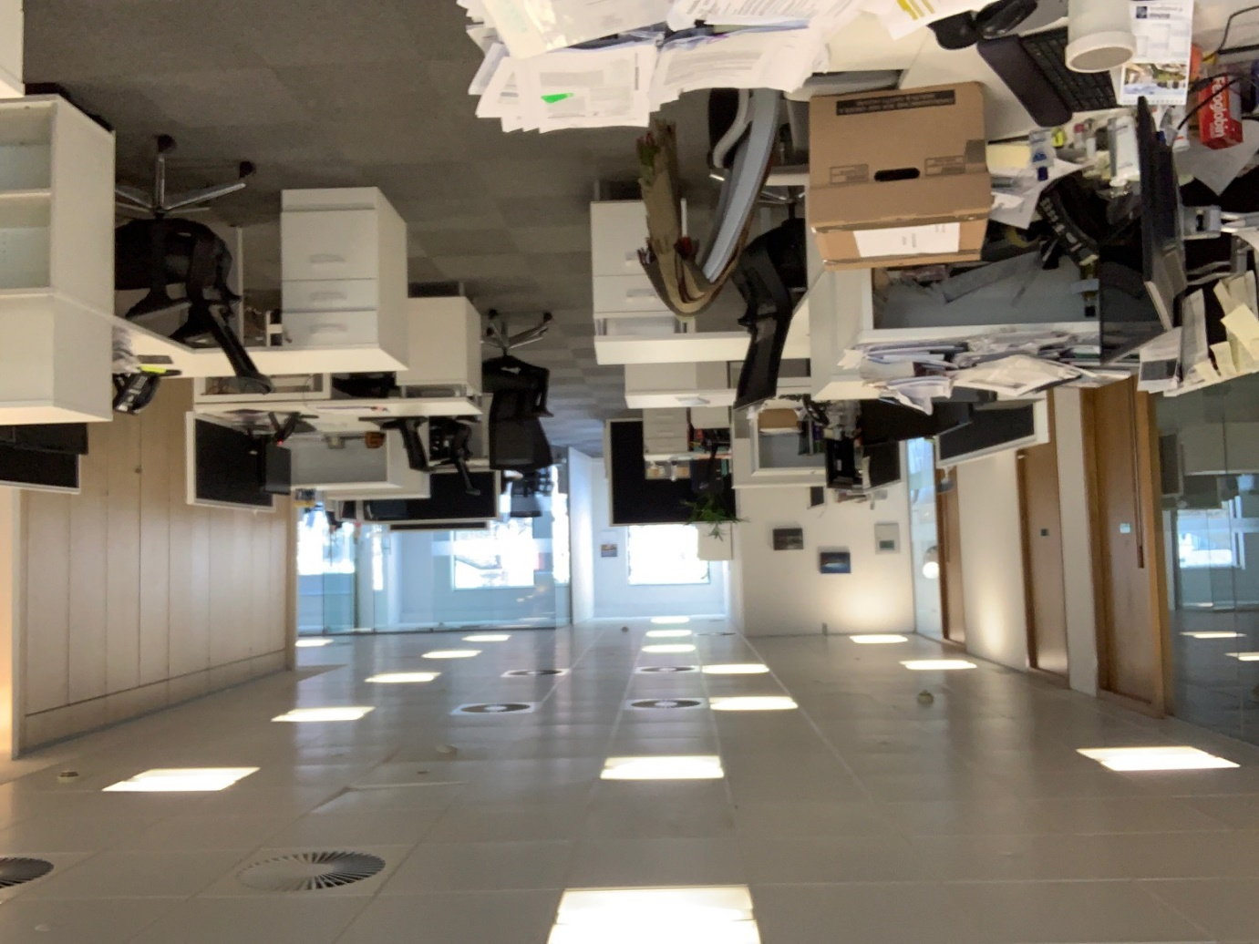

Gill Household

Following Tooth Fairy-gate, and after a careful review of news sources this week my son pointed me to this BBC news article confirming that both the Tooth Fairy and the Easter Bunny are essential workers.

https://www.bbc.co.uk/news/av/world-asia-52189013/jacinda-ardern-tooth-fairy-and-easter-bunny-are-essential-workers

I am sure this will come as a relief to many.

Have a good Easter break!

BC Contacts
    - Alex Hughes 07748 857114
    - Karen Genuardi 07801 523186
    - Ian Gill 07782 248216
    - Vince Bixby 07725 900367
    - Claire Pitman 07956 862824
    - Craig Turner 07946 629052
    - Adrian Bennett 07817 894781
    - Soizic Peyrusse 07786 683709
    - Alok Suthar 07877 350839

The BC Team

Ian Gill
Partner, Patent & Trade Mark Attorney
DL: +44 (0) 20 7440 6841 E: isg@aathornton.com
W: aathornton.com

A.A. Thornton & Co.
10 Old Bailey
London, EC4M 7NG
T +44 (0) 20 7405 4044
F +44 (0) 20 7405 3580
COVID-19 - At AA Thornton we are well equipped to proceed with business as usual, and to provide uninterrupted, high-quality service to our clients. Please click here for our latest update.

