Hi

**Mental Health Awareness Week / Alzheimer’s Society Fund Raiser**

As a result of last week’s collective fundraising efforts we have managed to raise an incredible £1726 for the Alzheimer’s Society. From theatrical masterpieces to crippling endurance feats – it has been heart-warming to see so many people get involved in aid of this worthy cause and to raise awareness about the importance of good mental health at the same time. The Just Giving page will remain open for the rest of this week for anyone still hoping to make a donation: <https://www.justgiving.com/fundraising/lockdownfundraising>.

We would like to recognise all of you who actively took part in the challenge event -  sporting / other achievements so if you haven’t already, please send us your sporting challenge results (miles run or rowed, walked etc), and any pictures you would be happy to share and we will gather those together and show everyone how we all got on.  Also we thought we might put together a LinkedIn posting to show the world how brilliant we are ☺.  **Please send timings and pics to Vic and Karen by 10am tomorrow.**

**Hats off to Elec!**

Here are some photos from the Elec team chat last week – the theme, if you cannot tell, was hats.

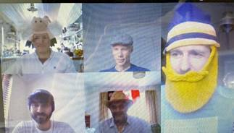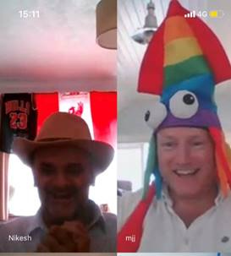

**Competition time**

Well done (again) to Nick South who was closest to the correct time of 1.51.  The grand prize of £25 will be sent shortly.  Is this destined for the Alzheimer’s Society, Nick?  I am still plucking up courage to release the final video but here is a clip showing how it should be done.  This is what I thought I looked like when I was “dancing” …

<https://www.youtube.com/watch?v=mF4tm0VIKAY>

**Gill Household**

We have now had our third lockdown birthday – this time it was mine on Friday.  I was delighted to get a handmade card from my daughter.  Until I read the text.

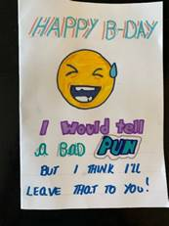

The fourth and final lockdown birthday will be in September … will we still be in lockdown then?!

**BC Contacts**

* + - Karen Genuardi    07801 523186
    - Ian Gill                   07782 248216
    - Vince Bixby           07725 900367
    - Claire Pitman        07956 862824
    - Craig Turner          07946 629052
    - Adrian Bennett      07817 894781
    - Alok Suthar           07877 350839

|  |  |
| --- | --- |
| Ian Gill Partner, Patent & Trade Mark Attorney | |
| **DL:** +44 (0) 20 7440 6841 **E:** [isg@aathornton.com](mailto:isg@aathornton.com)  **W:** [aathornton.com](http://www.aathornton.com/) | [Linkedin](https://www.linkedin.com/company/aathornton)[Twitter](https://twitter.com/AAThorntonCo) |

|  |  |
| --- | --- |
| AA Thornton & CO | **A.A. Thornton & Co.** 10 Old Bailey London, EC4M 7NG T +44 (0) 20 7405 4044 F +44 (0) 20 7405 3580 |
| COVID-19 - At AA Thornton we are well equipped to proceed with business as usual, and to provide uninterrupted, high-quality service to our clients. Please click [here](http://www.aathornton.com/covid-19/) for our latest update. | |

