Hi

**Mental Health Awareness Week / Alzheimer’s Society Fund Raiser**

We smashed it!…..the fundraising total is at **£2131!**

The videos and the pics that everyone has sent in are on the intranet Home Working page and some are below.  Well done everyone.

Here is a reminder of all the sporting challenges and achievements last week:

-Sarah Neil cycling her 95 mile commute on an exercise bike over the course of the week

-Stuart Greenwood running two half-marathons in a single day

-Marianne Privett running her 8 mile commute throughout the course of the week

-Craig Turner rowing his 16.5 mile commute over the course of the week

-Geoff Hussey running his 8.6 mile commute in a single day

-Mike Jennings running his 66 mile commute over the course of the week

-Jill Wilson hiking her 16 mile commute over the course of the week

-Victoria Jones running her 1.6 mile commute there and back every day of the week

-Alex Bone running his 38.5 mile commute over the course of the week

-Susie Power running her 20.1 mile commute over the course of the week

-Becca Brenton running her 3.5 mile commute every day of the week

-Holly Smith riding her 38 mile commute on horseback

            -Karen Genuardi running 29 miles over 7 days (smashed her return commute of 24 miles)

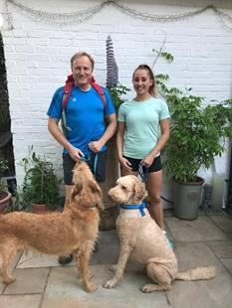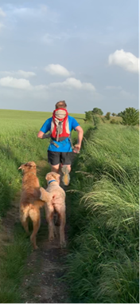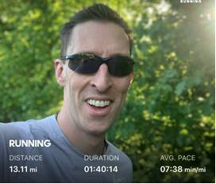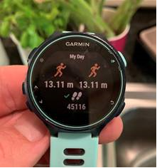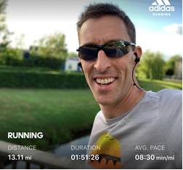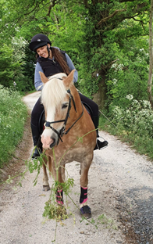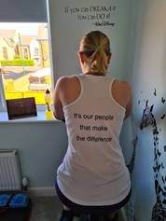

The Just Giving page will remain open for a few more days.  Vic/Karen will posting a LinkedIn update with some of your pics and the swan lake video (well if it pushes the fundraising further then it must be worth sharing it….right?)

<https://www.justgiving.com/fundraising/lockdownfundraising>.  Please share the link.

The Wellness Champions are giving some further thought on ongoing AATea Time Socials…..further info to follow.

**BC Team**

We have new member of the BC Team – welcome Dan.  We have already warned Dan that the group is not as much fun as we make it look from the updates ;-)

**Competition time**

After the excitement of last week we are back to “*Where’s Ian?”* with a couple of twists.  Firstly it is a rollover week so there is a MASSIVE £50 on offer. Secondly, this week you are trying to guess where Craig was standing!  Will the competition excitement ever stop?!

Nick is going for a hat-trick of wins – will anyone be able to stop him?

Answers by 10am on Monday as usual please.

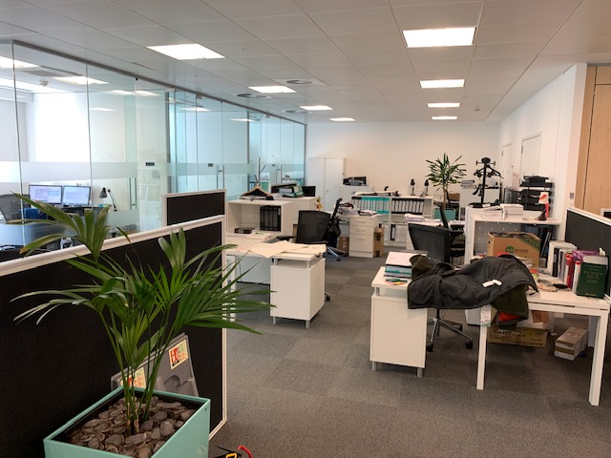

**BC Contacts**

* + - Karen Genuardi    07801 523186
    - Ian Gill                   07782 248216
    - Vince Bixby           07725 900367
    - Claire Pitman        07956 862824
    - Craig Turner          07946 629052
    - Adrian Bennett      07817 894781
    - Alok Suthar           07877 350839
    - Dan Bryne             07503 475521

|  |  |
| --- | --- |
| Ian Gill Partner, Patent & Trade Mark Attorney | |
| **DL:** +44 (0) 20 7440 6841 **E:** [ian.gill@aathornton.com](mailto:ian.gill@aathornton.com)  **W:** [aathornton.com](http://www.aathornton.com/) | [Linkedin](https://www.linkedin.com/company/aathornton)[Twitter](https://twitter.com/AAThorntonCo) |

|  |  |
| --- | --- |
| AA Thornton & CO | **A.A. Thornton & Co.** 10 Old Bailey London, EC4M 7NG T +44 (0) 20 7405 4044 F +44 (0) 20 7405 3580 |
| COVID-19 - At AA Thornton we are well equipped to proceed with business as usual, and to provide uninterrupted, high-quality service to our clients. Please click [here](http://www.aathornton.com/covid-19/) for our latest update. | |

