Morning
Wellness
Jill has also posted information about an NHS to help people to assess/better understand any feelings of anxiety/depression they may experience particularly as a result of our lives changing in such a short space of time, including lockdown and managing the stresses of working from home, furloughing, financial worries etc. https://www.nhs.uk/conditions/stress-anxiety-depression/mood-self-assessment/. This may be useful to you or a family member and as it is an external link the results are not accessible by AAT. Once you have completed the assessment tool some useful resources will be identified. You can also speak to your line manager, Karen/Jilly or utilise the Employee Assistance Programme: www.healthassuredeap.com or contact 0800 030 5182. To gain access to the Health and Well-being Portal you will require the below login credentials: Username: A.A Password: Thornton.
Privett Household

Marianne’s daughter invested her £25 winnings from the Office Olympics II in a Lottie doll, some toy money and Chitty Chitty Bang Bang on DVD. That is quite a mix!
Competition time

We are back to the regular competition slot filler of Where’s Ian? Normal rules apply. Mark you X where you think my head is located and return your guess for a chance at that huge £25 cash prize. If you win, will you spend as wisely as Marianne’s daughter?
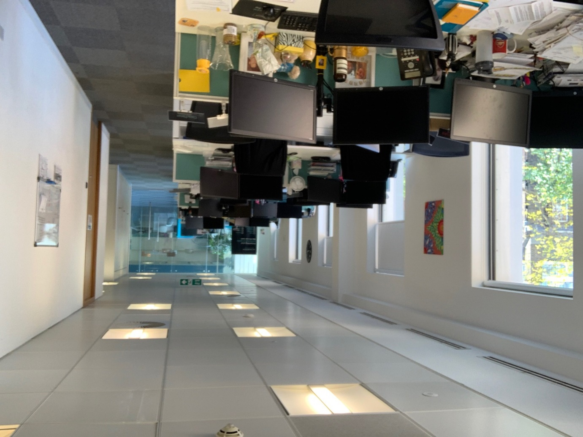
Guess need to be submitted by 10am on Monday.

Enjoy the long weekend!

BC Contacts
    - Karen Genuardi 07801 523186
    - Ian Gill 07782 248216
    - Vince Bixby 07725 900367
    - Claire Pitman 07956 862824
    - Craig Turner 07946 629052
    - Adrian Bennett 07817 894781
    - Alok Suthar 07877 350839

The BC Team

Ian Gill
Partner, Patent & Trade Mark Attorney
DL: +44 (0) 20 7440 6841 E: isg@aathornton.com
W: aathornton.com

A.A. Thornton & Co.
10 Old Bailey
London, EC4M 7NG
T +44 (0) 20 7405 4044
F +44 (0) 20 7405 3580
COVID-19 - At AA Thornton we are well equipped to proceed with business as usual, and to provide uninterrupted, high-quality service to our clients. Please click here for our latest update.

