Good morning all,

Mental Health Awareness week is now well underway, and hopefully you are beginning to feel the benefits of a little extra kindness in your day-to-day!

***Fundraising***

We wanted to offer a huge thanks to all those who have made fundraising pledges, shared our Just Giving link and donated in order to raise money for the Alzheimer’s Society. This collective effort has raised an impressive £891 so far! A donation which will no doubt help make a difference to the lives of a community of people that require more kindness than ever during this time.

***Film content***

As we are long past the £50 donation threshold, we are excited to release the first two videos of a series of entertaining content provided by members of the partnership and the wellness champions. If you are looking for some entertainment to get you through to the bank holiday, then look no further!

For those who have long pondered what Rachel would look like with a fro: <https://youtu.be/3F45v1FeeIk>

And for those looking to connect once again with the world outside your front door, allow Craig to take you on a journey: <https://youtu.be/HBQb9xVl5NM>

And there will be more content to come! For those eagerly awaiting Ian’s moving rendition of Swan Lake’s Dance of the Little Swans, here is a sneak peek: <https://youtu.be/MEzUy7y7kXk>.

And as teaser for Claire’s video…can you guess what item she tried to deliver to one of the partners this week?



***Acts of kindness***

We would love to hear of your acts of kindness, so we encourage you to share a photo or video of yourselves in the act (be that a fundraiser or otherwise) - snaps can be uploaded here (under “*upload your challenge pics here*”): <http://intranet.aat.local/wfh/_layouts/15/start.aspx#/SitePages/Home.aspx>. And for those of you seeking inspiration, some examples of acts of kindness can be found here: [LINK](http://intranet.aat.local/Lists/Announcements/DispForm.aspx?ID=2355&Source=http%3A%2F%2Fintranet%2Eaat%2Elocal%2FSitePages%2FHome%2Easpx&ContentTypeId=0x0104004C49FD337AA3604B8992F1E063B7CEDA). Marianne has taken the lead by gifting her children the opportunity to transform her by way of a paintbrush…so she spent much of the weekend as a pussycat and captain red beard. Great choices by all accounts.

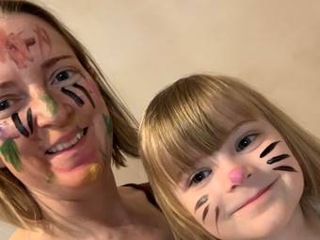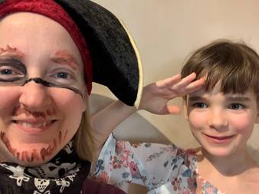

If you’d like to donate, or share our Just Giving page to encourage donations from friends or family (perhaps alongside a photo of you engaging in your act of kindness), the Just Giving page can be found here: <https://www.justgiving.com/fundraising/lockdownfundraising>.

***AATea-Time Chat***

Connecting with others regularly is essential to many people’s good mental health. Whilst we are all trying to keep connected whilst working through team catch ups and calls etc., as the prolonged absence from the office extends into May and June, I think we all (even the introverts) probably miss that social interaction with our people in the kitchen, over a cup of tea or lunch etc. Therefore, as a reminder, **the AATea-Time Chat is taking place at 3:00pm today**, where you can talk about how you have been getting on in the challenge event, share ideas, encourage each other, show off the cake you are eating, and of course chat about anything else (as long as it’s not work ☺)!  You should have a calendar invite for this but if not please speak to Jill ASAP. ***Line managers*** - please remind your furloughed staff about this too as we would love our furloughed team members to join in and ensure that everyone has a chance to participate ☺

Sending kind positive vibes,

The Wellness Champions & Vic

|  |  |
| --- | --- |
| Victoria Jones Trainee Patent Attorney | |
| **DL:** +44 (0) 20 7440 6865 **E:** [vej@aathornton.com](mailto:vej@aathornton.com)  **W:** [aathornton.com](http://www.aathornton.com/) | [Linkedin](https://www.linkedin.com/company/aathornton)[Twitter](https://twitter.com/AAThorntonCo) |

|  |  |
| --- | --- |
| AA Thornton & CO | **A.A. Thornton & Co.** 10 Old Bailey London, EC4M 7NG T +44 (0) 20 7405 4044 F +44 (0) 20 7405 3580 |
| COVID-19 - At AA Thornton we are well equipped to proceed with business as usual, and to provide uninterrupted, high-quality service to our clients. Please click [here](http://www.aathornton.com/covid-19/) for our latest update. | |

