Hi Everyone,

2020 couldn’t hold down the AAT Book Club for long and our first virtual meet took place this lunch time. We discussed Together by Julie Cohen, and what a talking point it was. I was counting the days until Book Club so I could talk to someone about it! (I may need to get out more… oh hang on..)

Our next book club will take place on Thursday 23rd July and we are going to discuss The Boy in the Striped Pyjamas by John Boyne.

If you don’t get round to reading the book feel free to pop along to join us for some lunch and a chat in the Virtual Kitchen, the last book certainly gave us lots to talk about, even for the people who hadn’t read it.

Thanks
Claire

P.S. If you normally get your books from the library but it’s still closed you can use “Libby”. Libby is a free app where you can borrow ebooks and digital audiobooks from your library. You can stream books with Wi-Fi or mobile data, or download them for offline use and read anytime, anywhere. All you need to get started is a library card (most libraries are allowing people to request one online at the moment if you don’t have one). Best of all, it’s free! ☺

Claire Pitman
Head of IP Operations
DL: +44 (0) 20 7440 6861 E: cep@aathornton.com
W: aathornton.com

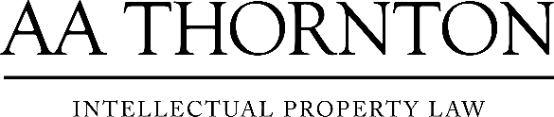 | A.A. Thornton & Co.  10 Old Bailey  London, EC4M 7NG  T +44 (0) 20 7405 4044  F +44 (0) 20 7405 3580
COVID-19 - At AA Thornton we are well equipped to proceed with business as usual, and to provide uninterrupted, high-quality service to our clients. Please click here for our latest update.

