Good morning All,

I provide below a link to another Communication Cascade video and ask that you watch this as soon as you can today. Some of you may also like to digest the Cascade in written form, so a transcript of the video will be uploaded to the Intranet shortly.

Please regard this communication as confidential to A A Thornton.

You should be able to view the video in your remote session, but if you copy and paste the link to the browser on your local laptop then you may find it works a little better. If viewing this email on a touch screen, then simply tap the link.

If you have any problems viewing the video then please send a report to: support@aathornton.com

Video link –

https://youtu.be/jnqT1tuHmCM

Many thanks,

Adrian

Adrian Bennett
Partner, Patent Attorney
DL: +44 (0) 20 7440 6831 E: adrian.bennett@aathornton.com
W: aathornton.com

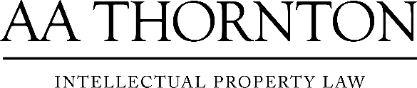 | A.A. Thornton & Co.  10 Old Bailey  London, EC4M 7NG  T +44 (0) 20 7405 4044  F +44 (0) 20 7405 3580
COVID-19 - At AA Thornton we are well equipped to proceed with business as usual, and to provide uninterrupted, high-quality service to our clients. Please click here for our latest update.

