Hi

**Comms Cascade**

Here is a link to Adrian’s most recent comms cascade.

<https://youtu.be/00H2L7dXDgM>

**SurveyMonkey**

Here is a link to the SurveyMonkey regarding office requirements for completion by noon on Wednesday 3 June.

<https://www.surveymonkey.co.uk/r/9GW892Z>

**Competition time**

This was a hotly contested competition, no doubt because of the massive £50 roll over prize.  The competition was close enough to be classed as a photo finish, but the winner, by a short neck, was … **Becca**!

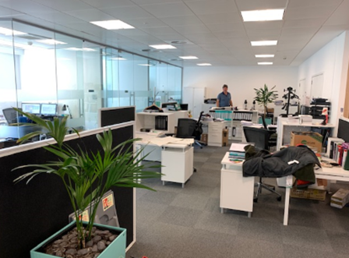

Nikesh – I can’t believe you fluffed this one - you have put every other entry at the centre back – this round was made for you!  Why change tactics now?!

Nick – the wait for a hat-trick continues …

A commendation goes to Lindsey for her imaginative use of a green bust to represent Craig’s head!

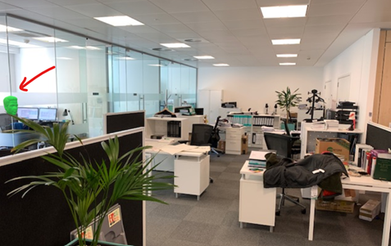

**BC Contacts**

* + - Karen Genuardi    07801 523186
    - Ian Gill                   07782 248216
    - Vince Bixby           07725 900367
    - Claire Pitman        07956 862824
    - Craig Turner          07946 629052
    - Adrian Bennett      07817 894781
    - Alok Suthar           07877 350839
    - Dan Byrne             07503 475521

|  |  |
| --- | --- |
| Ian Gill Partner, Patent & Trade Mark Attorney | |
| **DL:** +44 (0) 20 7440 6841 **E:** [isg@aathornton.com](mailto:isg@aathornton.com)  **W:** [aathornton.com](http://www.aathornton.com/) | [Linkedin](https://www.linkedin.com/company/aathornton)[Twitter](https://twitter.com/AAThorntonCo) |

|  |  |
| --- | --- |
| AA Thornton & CO | **A.A. Thornton & Co.** 10 Old Bailey London, EC4M 7NG T +44 (0) 20 7405 4044 F +44 (0) 20 7405 3580 |
| COVID-19 - At AA Thornton we are well equipped to proceed with business as usual, and to provide uninterrupted, high-quality service to our clients. Please click [here](http://www.aathornton.com/covid-19/) for our latest update. | |

