Hi

**10OB-exit**

If you are coming to the office to collect your personal possessions, and you have not yet booked your slot, please do so **today** using the link on page 2 of the attached PDF document.



**HAPPY PRIDE!**



It’s Pride Month 2020, and the Diversity and Inclusion Committee would like to share a series of blog posts with you that ***Careers in Ideas, as part of IP Inclusive,*** are creating this month.  Their aim – and ours – is to show that LGBT+ people can be free to be themselves in a profession that wants to be inclusive and welcoming for all. Nobody should have to hide aspects of their identity either to get a job in, or when they start work in, the IP sector.

The Careers in Ideas series begins with B’s story. B works in Internal Communication at the IPO and reflects on personal experience of coming out to colleagues. You can read B’s story [here](http://careersinideas.org.uk/article/pride-month-2020-being-out-and-proud-in-the-ip-profession/). Please check out other posts in this series too, as they are being posted each Monday in June and, for future posts, visit the [News page](http://careersinideas.org.uk/news-events-advisor/) of the Careers in Ideas website.

Also, [IP Inclusive](https://ipinclusive.org.uk/) have a brilliant, thought-provoking piece about the role of “allies” and how that’s likely to change as we emerge from the coronavirus lockdown. You can read this story [here](https://ipinclusive.org.uk/newsandfeatures/the-role-of-allies-in-a-post-pandemic-ip-profession/).

For other articles on the LGBT+ community, please also check out these links about [Section 28](https://ipinclusive.org.uk/newsandfeatures/section-28/), the Government-led ruling that has now thankfully been abolished and other changes coming in to affect in the near future, and a [curated reference guide](https://ipinclusive.org.uk/newsandfeatures/lgbt-a-curated-reference-guide/), both written during LGBT+ History Month back in February 2020.

**Home office set up**

Sarah D has provided the useful link below from a friend (and now a client ☺) who is a physio and runs Octopus Clinic in Blackfriars and Holborn. She has created the YouTube video below about how to set up a comfortable work station at home.  Sarah found the video helpful and thought it might be useful to others.

<https://youtu.be/-U05kDQgd1Y>

**Competition time**

Another special guest appearance this week in the “Spot the Sarah Gibson?” competition – can you guess who the special guest is?  No, guessing the special guest is not the competition.  Just make your mark where you think Sarah was standing before the attached photo of the empty office was taken.  Answers by Monday at 10am please.  Nikesh, are you going back to your “usual” guess or going off-piste again?

Rachel has donated her winnings from last week to Battersea Dogs and Cats Home.  She declined the suggestion that we donate to a snake-related charity like the Amphibian and Reptile Trust -  <https://www.arc-trust.org/snakes-in-gardens>.  However the strong support for a snake in the next office has been noted!

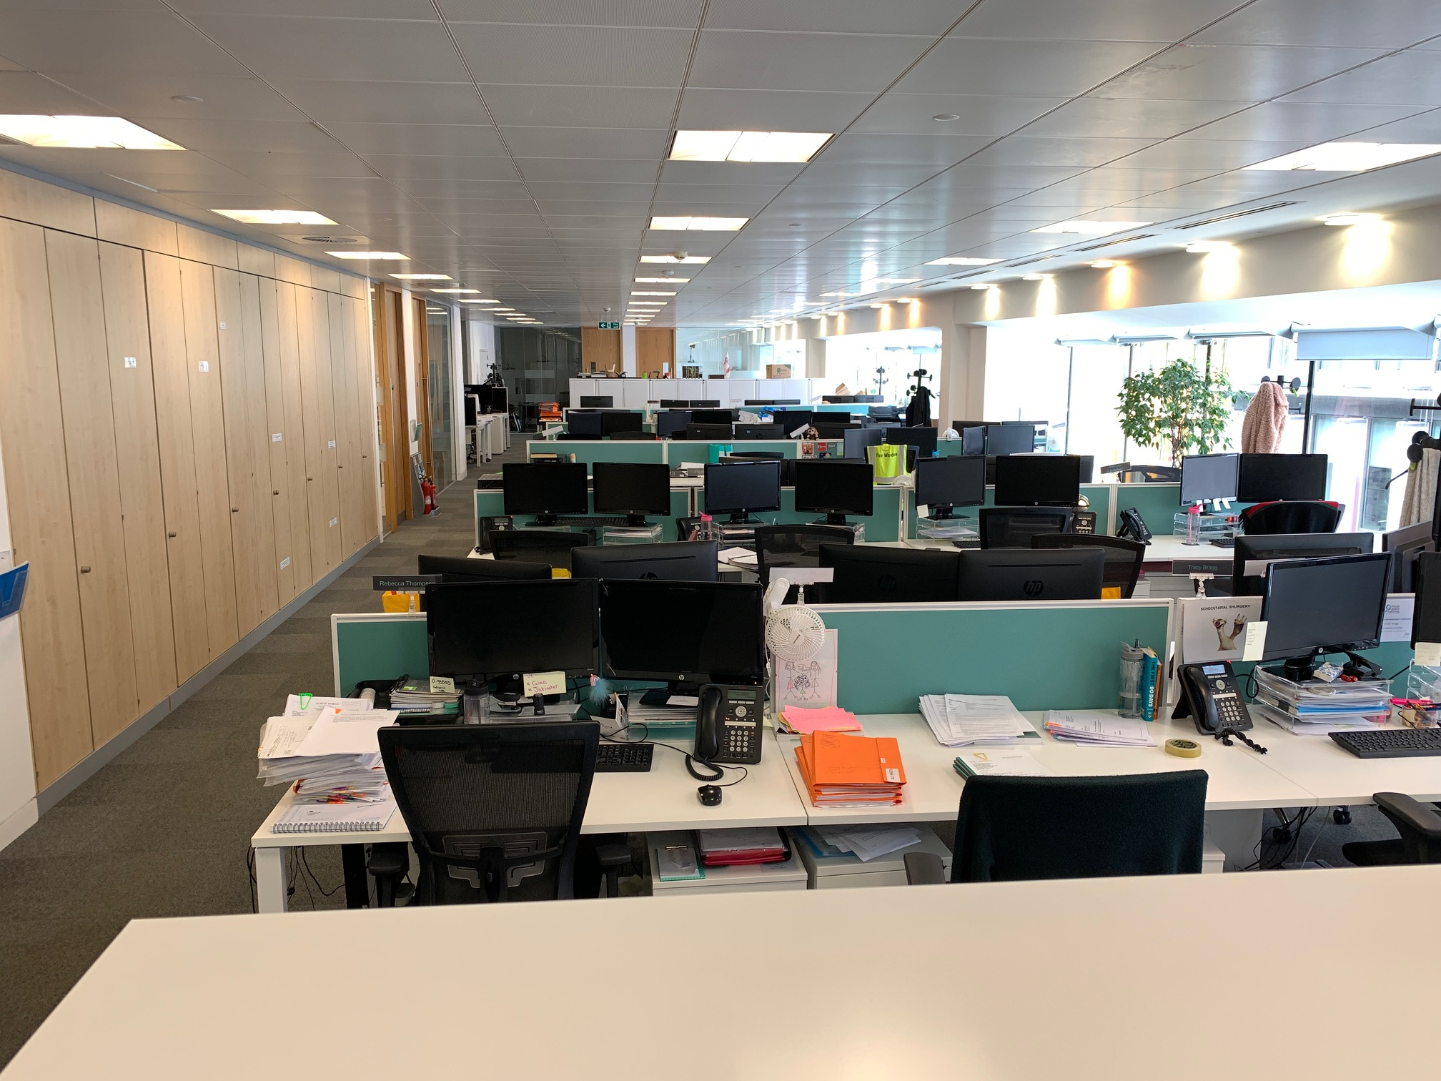

**Gill Household**

As the lockdown eases, step by step, we are hoping for the best but planning for the worst.  We had a family chat the other day to discuss whether there was anything we should stockpile in case there is a second wave and we agreed on Heinz Baked Beans – nothing else – just “real” baked beans!  What is on your list of essentials?

**BC Contacts**

* + - Alex Hughes         07748 857114
    - Karen Genuardi    07801 523186
    - Ian Gill                   07782 248216
    - Vince Bixby           07725 900367
    - Claire Pitman        07956 862824
    - Craig Turner          07946 629052
    - Adrian Bennett      07817 894781
    - Alok Suthar           07877 350839

|  |  |
| --- | --- |
| Ian Gill Partner, Patent & Trade Mark Attorney | |
| **DL:** +44 (0) 20 7440 6841 **E:** [isg@aathornton.com](mailto:isg@aathornton.com)  **W:** [aathornton.com](http://www.aathornton.com/) | [Linkedin](https://www.linkedin.com/company/aathornton)[Twitter](https://twitter.com/AAThorntonCo) |

|  |  |
| --- | --- |
| AA Thornton & CO | **A.A. Thornton & Co.** 10 Old Bailey London, EC4M 7NG T +44 (0) 20 7405 4044 F +44 (0) 20 7405 3580 |
| COVID-19 - At AA Thornton we are well equipped to proceed with business as usual, and to provide uninterrupted, high-quality service to our clients. Please click [here](http://www.aathornton.com/covid-19/) for our latest update. | |

