12 June
BC team – 10OB-exit
Please remember to wear a face covering if you are travelling to the office on public transport.
If your packing/storage requirements fall under Option 3 or you are helping to pack up someone else’s belongings to be sent home (Option 4), as a reminder please email office.services@aathornton.com letting us know how many boxes you have packed ready for delivery to yours or someone else’s address. Please provide names and numbers of boxes.
A reminder of these 2 options (please also refer to the full instructions attached):
Option 3:

I am coming to remove my own personal effects and require some items to be sent home.
- Please take home on the same day any items that you are able to.
- For the rest of the items, please use the boxes provided to pack up the personal & agreed work related items that you wish to be sent home into the boxes provided. This should not include any IT items or furniture. These items should have been identified on the recent survey and will be organised separately for you.
- Do not over pack the boxes. Lids should close securely.
- Label your box (lid and side) with your allocated number.
- Leave the box on your desk top, or directly underneath your desk in easy view.
- Please email office.services@aathornton.com letting us know how many boxes you have packed ready for delivery to your address.
Option 4:

I am not coming into the office but require some personal / work items to be sent home to me.
- We will organise someone to video call you to organise the packing of your personal or work effects that need to be sent to your address. This should not include any IT items or furniture. These items should have been identified on the recent survey and will be organised separately for you.
- The packer will let us / you know how many boxes that are packed ready for delivery to your address. Please email office.services@aathornton.com letting us know how many boxes you have packed ready for delivery to your address.
Furloughing Update
We thought it would be helpful to provide you with a brief update on the Job Retention Scheme and current furloughing arrangements. The Government have extended the scheme to the end of October 2020, and there are some key changes to the arrangements and the furlough grant arrangements. We are awaiting full details of the changes so that we can decide how best to utilise the scheme and the flexibility on offer going forward and will keep you updated. In the meantime, here are the main updates:
- The deadline for final furloughing was 10 June 2020 – therefore if you have not been furloughed already you will not be asked to do so;
- From 1 July, anyone that has been furloughed prior to the end of June for at least 3 weeks remains eligible to be furloughed either full time or on a flexible part time basis that is agreed between employers and employees. A list of people who have been furloughed is available on the intranet.

If anyone has any questions about furloughing that are not yet covered by the FAQ’s then please speak to your line manager or Karen.
Competition time

Here is the answer and well done to Becca!
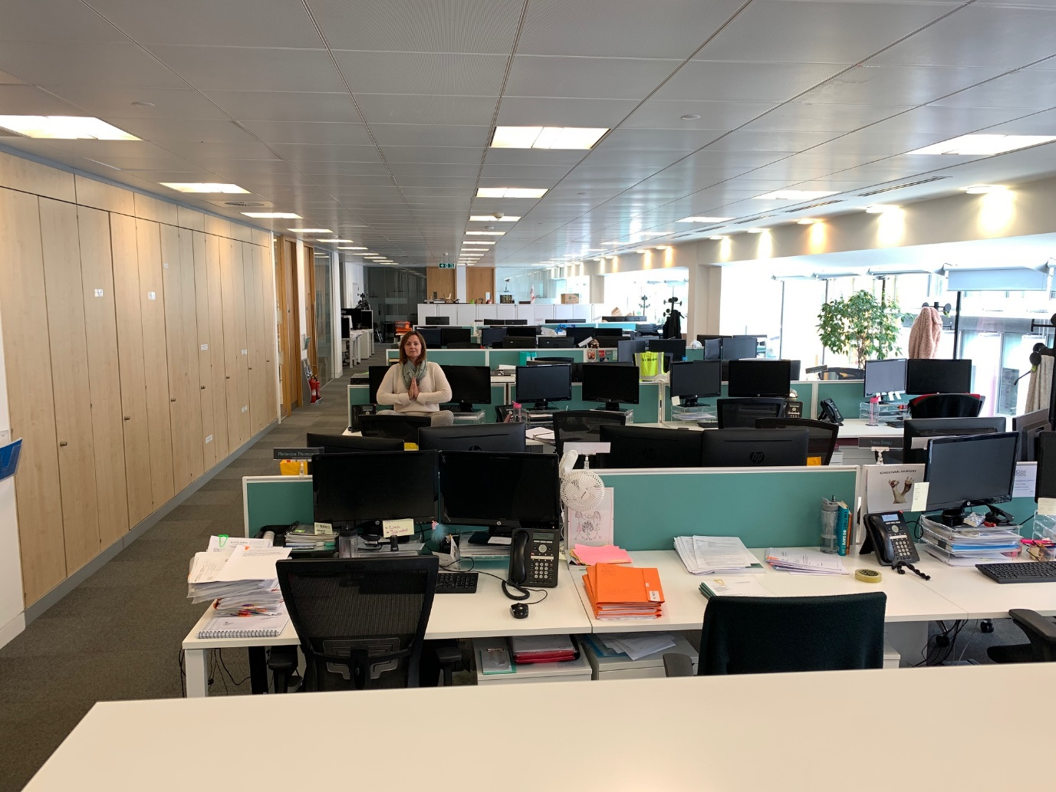

Nikesh, you were quite close this time, but for the wrong reasons … keep plugging away!

BC Contacts
    - Alex Hughes 07748 857114
    - Karen Genuardi 07801 523186
    - Ian Gill 07782 248216
    - Vince Bixby 07725 900367
    - Claire Pitman 07956 862824
    - Craig Turner 07946 629052
    - Adrian Bennett 07817 894781
    - Alok Suthar 07877 350839

Ian Gill
Partner, Patent & Trade Mark Attorney
DL: +44 (0) 20 7440 6841 E: isg@aathornton.com
W: aathornton.com

A.A. Thornton & Co.
10 Old Bailey
London, EC4M 7NG
T +44 (0) 20 7405 4044
F +44 (0) 20 7405 3580
COVID-19 - At AA Thornton we are well equipped to proceed with business as usual, and to provide uninterrupted, high-quality service to our clients. Please click here for our latest update.

