Hi

**BC team – 10OB-exit**

This week furniture and other moveable fittings will be removed from 10OB and put into storage.

Personal possessions with any furniture and IT equipment that have been requested will be delivered to you this week or next week.  If you need help with IT equipment, particularly the connection of a second monitor, please log a ticket and be patient!

Our expectation is that our IT systems will be offline from Friday evening on 26 June til Monday morning on 29 June.

**To minimise the impact of any delay with the restart of normal service on Monday 29 June please, by Friday 26 June:**

1. **attend to any deadlines and new filings due in the week of 29 June, as far as client instructions allow;**
2. **Treat 26 June as the end of month for invoicing purposes.**

**Remote Working Asset Register**

Sorry if you could not open the embedded file within the previous email.  The how to file is attached to this email. Please ensure that you complete the ‘Remote Working Asset Register’ form within Cezanne to state any AAT equipment you took home/were sent once this has all been received. Please see the how to guide attached for more details. If you are on furlough, please email Jill ([jlw@aathornton.com](mailto:jlw@aathornton.com)) stating what you have so this can be added to the system for you.



**Competition time**

This contest turned out to be a tale of two competitions – the numerous people who guessed Sri Lanka, or thereabouts, and the small number of others who did not.    Oh and Wendy who went for “*Anywhere but here*” – that is correct Wendy but insufficiently specific to win.

The answer was Marrettimo, an island off Sicily, where Varuni was on holiday last year.  The map below shows the location along with one of Varuni’s holiday snaps to make you feel jealous.

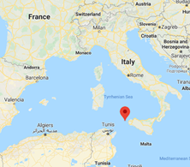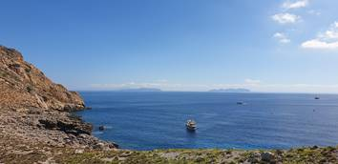

Remarkably this location suited Nikesh’s “*always put the cross in the middle*” tactic and he is the winner this week!  Well done Nikesh, you had to win eventually – a bit like Liverpool …

**BC Contacts**

* + - Alex Hughes         07748 857114
    - Karen Genuardi    07801 523186
    - Ian Gill                   07782 248216
    - Vince Bixby           07725 900367
    - Claire Pitman        07956 862824
    - Craig Turner          07946 629052
    - Adrian Bennett      07817 894781
    - Alok Suthar           07877 350839

