Hi All,

In this week’s AAT Film Club we discussed the film Captain Fantastic (available on Netflix). We all agreed it was an enjoyable film (surely this cannot last), some laugh out loud moments, some tears (maybe just me but I cried at an episode of Wheel of Fortune once). We thought it was a great film club choice as it was very thought provoking:

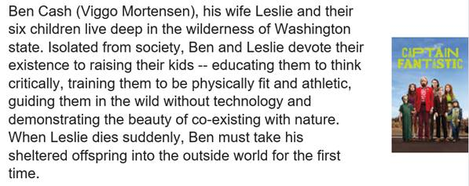

We also got to see Nick’s “virtual kitchen” with another one next week, but will it be his *actual* kitchen?!? The excitement never ends over in the AAT virtual kitchen!

If you have any suggestions for the next film please let the Wellness Champs know.  The film Enemy starring Jake Gyllenhaal is still in discussion as a possible contender for Film club. One member went and watched it and thought it was “brilliant” whereas Ian’s one word description is not really printable. If a film is that polarising surely it’s the natural fit for a film club….

Thanks

Claire

|  |  |
| --- | --- |
| Claire Pitman Head of IP Operations | |
| **M:**  **E:** [cep@aathornton.com](mailto:cep@aathornton.com)  **W:** [aathornton.com](http://www.aathornton.com/) | [Linkedin](https://www.linkedin.com/company/aathornton)[Twitter](https://twitter.com/AAThorntonCo) |

|  |  |
| --- | --- |
| AA Thornton & CO | **A.A. Thornton & Co.** 10 Old Bailey London, EC4M 7NG T +44 (0) 20 7405 4044 F +44 (0) 20 7405 3580 |
| COVID-19 - At AA Thornton we are well equipped to proceed with business as usual, and to provide uninterrupted, high-quality service to our clients. Please click [here](http://www.aathornton.com/covid-19/) for our latest update. | |

Hi all

Thank you to those who attended the film club on Monday, and Claire for her email following this.

The next film club will take place on Monday 20 July and we are going to discuss ‘Two Days, One Night’, available on BBC iPlayer.

Even if you don’t get round to watching it before we meet still feel free to pop along and join us for a chat in the Virtual Kitchen on MS Teams ☺

If you can’t make the 20 July but have suggestions for what we can watch next, please email me before/on 20 July.

Kind regards

Jilly