Hi
Office accommodation
There seems to be some tension between the government and the scientists at the moment with Boris making comments about “getting back to work” and the government’s scientific advisor saying that there is absolutely no reason to change the guidance on working from home.
Whilst we plan for our next long-term home, our agreement at 15 Old Bailey, which is provided by The Argyll Club and is currently an address for post only, allows us to be flexible in taking any number of private desk spaces at any location across their various London offices when we are ready to. Their operation means that we can size this requirement up or down on demand, and could also allow us to make use of additional flexible solutions such as ‘co-working’, which allows individuals to drop in and work in open but professional environments in different locations. Our new IT set up means that we are perfectly placed to move very quickly to open up office space at the appropriate point.
Whilst we have not taken either the private desk space or co-working flexibility yet, we are able to book meeting rooms on a pay-per-use basis for meetings and oral proceeding or the like whenever we need them. Please speak to AWH for the contact details to arrange this.
We expect to take some private desk space once we are able to use it based on government guidelines and we expect to be continue our agreement with The Argyll Club for the rest of 2020 whilst we assess what we will need from our new permanent space.
p.s this was prepared before Boris’ announcement at 11am! We will consider the new guidance.
Office Phone requirements
Please complete the survey today if you have not already done so.
MS Teams is not the only game in town …
There are other options for internal video catch ups if you have had enough of Teams.
Whereby offers free signup and screen saving for groups of up to 4 people.
LIfesize allows for larger groups and variation of video quality.
Trials with both systems have produced good results.
Competition time

You can take the firm out of the office but you can’t the office out of the competition! (I know, I’m stretching here.) Back for an extra special guest appearance in ‘Where’s Ian?’ is Craig! Guess where he is to win the BIG cash prize!

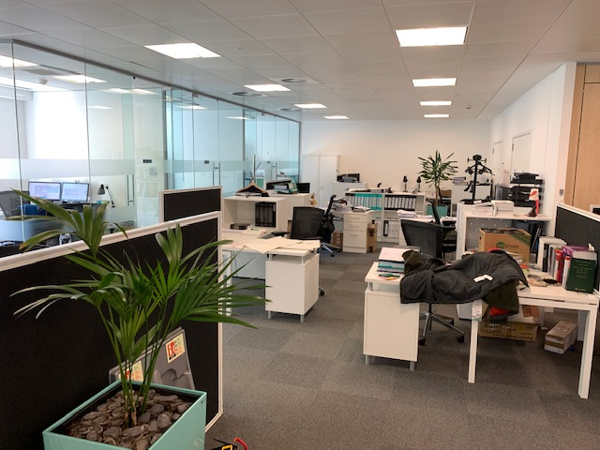
Have a good weekend.

BC Contacts
    - Alex Hughes 07748 857114
    - Karen Genuardi 07801 523186
    - Ian Gill 07782 248216
    - Vince Bixby 07725 900367
    - Claire Pitman 07956 862824
    - Craig Turner 07946 629052
    - Adrian Bennett 07817 894781
    - Alok Suthar 07877 350839

Ian Gill
Partner, Patent & Trade Mark Attorney
M: 07782248216
E: isg@aathornton.com

AA Thornton 15 Old Bailey, London, EC4M 7EF
T: +44 (0) 20 7405 4044 F: +44 (0) 20 7405 3850 W: aathornton.com
Please note the change in our address to 15 Old Bailey, EC4M 7EF. COVID-19 - At AA Thornton we are able to continue to provide an uninterrupted, high-quality service to our clients. Please click here for our latest update.

