Hi

Office Space

A survey will be sent later this week seeking your input on how often you would like to work in an office during August and September so we can plan a safe return to work for those who are interested in office-based working during that period.

Remote Working Asset Register

We are still awaiting a number of ‘Remote Working Asset Register’ forms with Cezanne stating any AAT equipment you took home/were sent. Please can you complete this by 24 July 2020. Please see the how to guide attached for more details. If you are on furlough, please email Jill (jlw@aathornton.com) stating what you have so this can be added to the system for you.

Home Working DSE Risk Assessment

As mentioned previously, we would like to ensure that you are all working as safely as possible and understand where there may be outstanding issues still to resolve now that all equipment and furniture from the office has been delivered. If you haven’t completed the attached DSE homeworking risk assessment, please can you complete this as soon as possible any by the end of July 2020 at the latest. This can be sent to Jill, marked private, and the relevant BC team members will go through these and follow up with anyone where there are concerns.

Competition time

Craig was right in your face this time! Quite a few of you were close but Susie scrapped it by long lockdown haircut! Well done Susie!
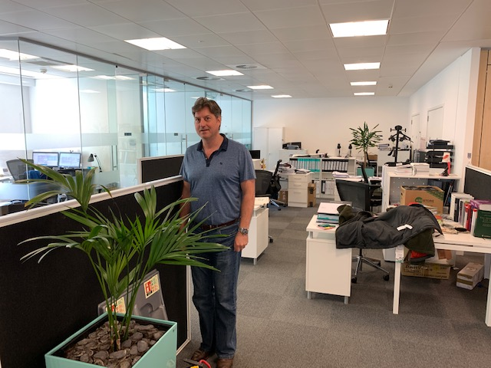

BC Contacts
    - Alex Hughes 07748 857114
    - Karen Genuardi 07801 523186
    - Ian Gill 07782 248216
    - Vince Bixby 07725 900367
    - Claire Pitman 07956 862824
    - Craig Turner 07946 629052
    - Adrian Bennett 07817 894781
    - Alok Suthar 07877 350839
Ian Gill
Partner, Patent & Trade Mark Attorney
M:
E: ian.gill@aathornton.com

AA Thornton 15 Old Bailey, London, EC4M 7EF
T: +44 (0) 20 7405 4044 F: +44 (0) 20 7405 3850 W: aathornton.com
Please note the change in our address to 15 Old Bailey, EC4M 7EF. COVID-19 - At AA Thornton we are able to continue to provide an uninterrupted, high-quality service to our clients. Please click here for our latest update.

