Hi

**10OB-exit**

**IT infrastructure move**

Further work will take place this weekend to resolve the remaining issues relating to the intranet and the lack of local internet access when you have a Forticlient connection.  The systems will be unavailable at various points during the weekend while this work is conducted.

**Other issues**

We will soon be seeking your input in relation to a revised phone system through a surveymonkey questionnaire.   The new system is highly configurable and can be adapted to suit your preferences but it may be a couple of weeks before it is available.

**GDPR Refresher e-Learning**

We are now ready to rollout out refresher training on GDPR, in line with our compliance obligations and best practice. As with the Anti-Bribery course, this comprises of two courses – one consisting of a general overview of GDPR from Riliance and one which contains some questions more specific to AAT and our policies. Please ensure you complete the GDPR courses by **31 July 2020** (it should take around 30 minutes to complete both parts).

The Data Protection Policy and Employee/Worker Privacy Notice is attached here, which you should read to remind yourself of your responsibilities, and please refresh your memory of the Privacy Policy (<https://www.aathornton.com/privacy-policy/>). You will receive an email from Riliance regarding the training – please remember to check your junk mail if you do not receive this by Wednesday 8 July 2020 and/or contact Jill.

Look out for the cookie question in the GDPR training!





**Remote Working Asset Register**

Please remember to  complete the ‘Remote Working Asset Register’ form within Cezanne to state any AAT equipment you took home/were sent, if you haven’t already. Please see the how to guide attached for more details. If you are on furlough, please email Jill ([jlw@aathornton.com](mailto:jlw@aathornton.com)) stating what you have so this can be added to the system for you.

**Home Working DSE Risk Assessment**

Now that some of you have received various deliveries of equipment and furniture from the office and/or have adapted to homeworking since lockdown, we would like to ensure that you are all working as safely as possible and understand where there may be outstanding issues still to resolve.  Please complete the attached DSE homeworking risk assessment and return it, marked private, to Jill, and the relevant BC team members will go through these and follow up with anyone where there are concerns.  **Please complete this as soon as possible and by the end of July 2020 at the latest.**



**Competition time**

We have not officially left 10OB yet so there is time for another guest “Spot the Ian” competition, this time featuring Adrian.

Make your mark as usual.  Nikesh, shall I just assume you will make the same guess as usual?

Answers be 10am on Monday please.

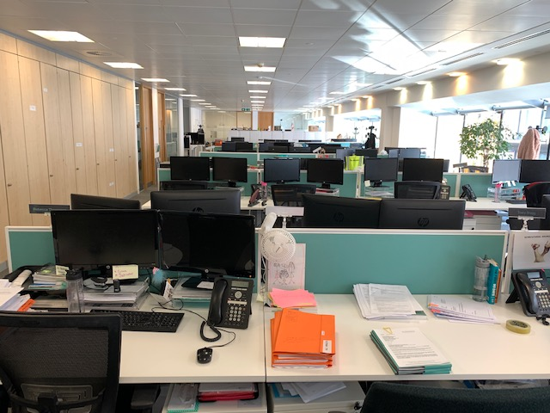

**BC Contacts**

* + - Alex Hughes         07748 857114
    - Karen Genuardi    07801 523186
    - Ian Gill                   07782 248216
    - Vince Bixby           07725 900367
    - Claire Pitman        07956 862824
    - Craig Turner          07946 629052
    - Adrian Bennett      07817 894781
    - Alok Suthar           07877 350839

|  |  |
| --- | --- |
| Ian Gill Partner, Patent & Trade Mark Attorney | |
| **M:** 07782248216 **E:** [isg@aathornton.com](mailto:isg@aathornton.com)  **W:** [aathornton.com](http://www.aathornton.com/) | [Linkedin](https://www.linkedin.com/company/aathornton)[Twitter](https://twitter.com/AAThorntonCo) |

|  |  |
| --- | --- |
| AA Thornton & CO | **A.A. Thornton & Co.** 10 Old Bailey London, EC4M 7NG T +44 (0) 20 7405 4044 F +44 (0) 20 7405 3580 |
| COVID-19 - At AA Thornton we are well equipped to proceed with business as usual, and to provide uninterrupted, high-quality service to our clients. Please click [here](http://www.aathornton.com/covid-19/) for our latest update. | |