Hi

**Office accommodation**

Thank you for responding to the survey.   As you can see from the chart below there is limited interest in working in a central London office in August and September for a variety of reasons but predominantly safety related.  However, we understand everyone’s homeworking experience is different and this present each of use with different challenges over a prolonged period.  Therefore, we are following up individually with everyone who expressed an interest in coming to the office in August/September to discuss what we can do to help them.  We will also follow up individually with anyone else who expressed negative views about their home working environment, to see where we can help make some improvements/discuss some solutions.

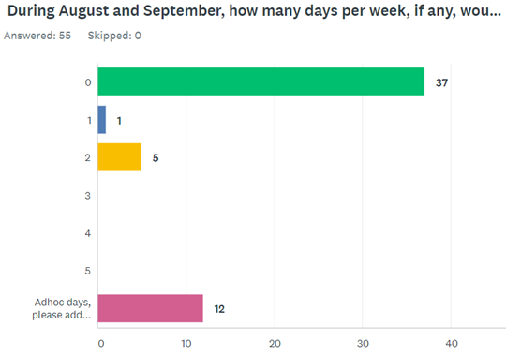

We will review the interest in a central office space again in mid-September.

**IT equipment**

This is a further reminder that if you need IT equipment to improve your home set up, such as a 2nd monitor or dock to enable connection to a 2nd monitor, and you have not already logged the ticket with [support@aathornton.com](mailto:support@aathornton.com) asking for that equipment, then please do so.

**Competition time**

We are going large with this one.  No really, we are.  I know I have said that before but I mean it this time.  **A new Apple Watch (Series 5, 44mm screen)** has come into our possession and we are just giving it away!

‘All’ you have to do is send in a photo (with or without family, friends, flatmates, pets or socially distanced passers-by - but the photo must include you and you must be recognisable) in your ‘Apocalypse Outfit’, either as you expected to look or how you actually look.  This competition was inspired by a photo Rachel sent to the TM fee earner WhatsApp group right back in the early days of the apocalypse.



You have until **24 August** to submit your photos and the winner will be announced on 28 August.  Marks will be award for:

* Adherence to Theme
* Uniqueness of Concept
* Humour
* Creativity
* Entertainment Quality
* Overall Artistic Impression
* Composition

**BC Contacts**

* + - Alex Hughes         07748 857114
    - Karen Genuardi    07801 523186
    - Ian Gill                   07782 248216
    - Vince Bixby           07725 900367
    - Claire Pitman        07956 862824
    - Craig Turner          07946 629052
    - Adrian Bennett      07817 894781
    - Alok Suthar           07877 350839
    - Dan Byrne             07503 475521

|  |  |
| --- | --- |
| Ian Gill **Partner, Patent & Trade Mark Attorney** | |
| **T:** +44 (0) 20 7440 6841 **E:** [isg@aathornton.com](mailto:isg@aathornton.com) | [Linkedin](https://www.linkedin.com/company/aathornton)[Twitter](https://twitter.com/AAThorntonCo) |

|  |  |  |
| --- | --- | --- |
|  | AA Thornton |  |
|  |  |
| **AA Thornton**  15 Old Bailey, London, EC4M 7EF   **T:**+44 (0) 20 7405 4044    **F:** +44 (0) 20 7405 3850    **W:**  [aathornton.com](http://www.aathornton.com) | | |
| Please note the change in our address to 15 Old Bailey, EC4M 7EF. COVID-19 - At AA Thornton we are able to continue to provide an uninterrupted, high-quality service to our clients. Please click [here](http://www.aathornton.com/covid-19/) for our latest update. | | |

