Hi
10OB-exit
IT infrastructure move
Following the messagebird text last night, all systems are operational and accessible via RDS. If you were using Forticlient then Vince will be in touch to reconfigure your VPN access.
RDS does not readily support dual-screen access but it is a useful temporary route into the system in business continuity situations. The reconfigured VPN access will allow dual-screen access.
If you have any other issues accessing the systems please log a ticket with support@aathornton.com.
External announcement of move
Our lease ends of 9 July and we will be sending out communications to clients on that date. Alex H will send a summary of the action that is being taken.
Competition time

Here is the photo with Adrian in - he was reluctant to show is lock-down haircut on camera so was lurking behind the coat stand on the right.

The winner is Dan! Well done.
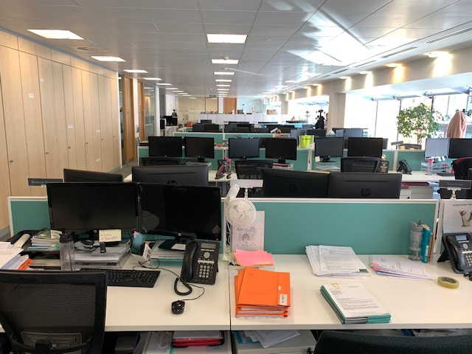
BC Contacts
    - Alex Hughes 07748 857114
    - Karen Genuardi 07801 523186
    - Ian Gill 07782 248216
    - Vince Bixby 07725 900367
    - Claire Pitman 07956 862824
    - Craig Turner 07946 629052
    - Adrian Bennett 07817 894781
    - Alok Suthar 07877 350839

Ian Gill
Partner, Patent & Trade Mark Attorney
M: 07782248216 E: isg@aathornton.com
W: aathornton.com

A.A. Thornton & Co.
10 Old Bailey
London, EC4M 7NG
T +44 (0) 20 7405 4044
F +44 (0) 20 7405 3580
COVID-19 - At AA Thornton we are well equipped to proceed with business as usual, and to provide uninterrupted, high-quality service to our clients. Please click here for our latest update.

