Remote desktop services is a service that AAT have deployed to allow access into the systems without the use of the AAT VPN. The service can be used from any computer that is connected to the internet and does not require the machine to be an AAT managed machine. This service has primarily been deployed to offer a no VPN version of Inprotech but can also be used to connect directly to any machine here in the office.
In Internet Explorer or Chrome |  |  | To access the service you will need to navigate to the following URL:  https://rds.aathornton.com/rdweb  Once at the link you will be presented with the screen as seen in the screenshot to the right.
In Remote desktop Services  (login) |  |  | To log into Remote Desktop Services (RDS) you will need to supply the credentials in the required two fields these credentials are the same as those that you use to log into your computer so it should look something like this:  Username: aat\vjb  Password: (same as the one you use to log in each morning).
Once logged in |  |  | Once you are logged into the service you will be shown the apps that are available to your user account, simply start the app by clicking on its icon in the webpage, by default we offer the following apps:  Remote Desktop – Allows you to log into your office desktop without access to the company VPN  Inpro – Allows access to Inpro without going over the company VPN.  Word – Used in conjunction with Inpro for reports  Excel – Used in conjunction with Inpro for reports |  |  |  | 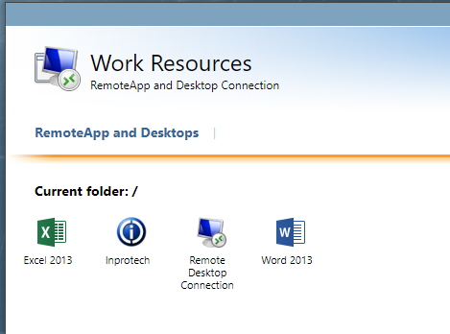
Starting the APP |  |  | Clicking on the application on the image above is not quite enough to make full use of the program and once clicked it will download a launcher at the bottom left of the browser window as shown in the image to the right.  If you click this downloaded file you will then be taken to the application, you will need to enter your domain username and password to progress.  Once in the RDP application you will be faced with the screen to the right:  - Put the name of your PC in the box labelled computer as shown  - Your username will also be required and is in the format aat\(initials).  - Put your password (for the pc in the office).  - Click connect. And you should be in the system. |  |  |  | 