Hi All

In this week’s AAT Film Club we discussed the film Knives Out (available on Amazon Prime).

Whilst we all enjoyed this film there was some comments about Daniel Craig’s accent in the film (some though it was along the lines of Dick Van Dyke’s terrible accent in Mary Poppins although some thought that had to be worse). It had a very good cast though, and definitely worth a watch.

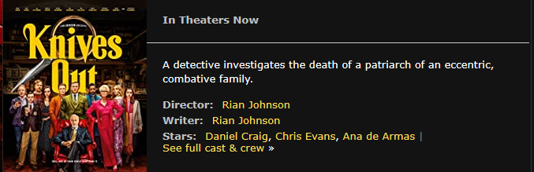

The next film club will take place at 5pm, on Tuesday 1 September (as Monday is a bank holiday) and we are going to watch is… duh duh dah…. The Host, which is our first horror film. This was filmed during lockdown and is based around six friends and their weekly zoom call, but strange occurrences start happening in their homes and they soon realise that they might not survive the night.

This is available on <https://www.shudder.com/movies/watch/host/b89c77f392b1c5e8?gclid=CjwKCAjw1ej5BRBhEiwAfHyh1BGLG1TDLwHTyc4OTpSJSGuV0UuSR21dQBTuGMMN1t5UAr8uWnS9fRoCbdIQAvD_BwE> and there is a 7 day free trial to watch the film.

Even if you don’t get round to watching it (or purposely avoid it if you are not a fan of horrors!) before we meet still feel free to pop along and join us for a chat in the Virtual Kitchen on MS Teams ☺

If you can’t make the 1 September but have suggestions for what we can watch next, please email me before/on 1 September.

Kind regards

Jilly

