Hi

**Competition**

There was a clear winner here … Well done to Hollie for the amazing entry below.

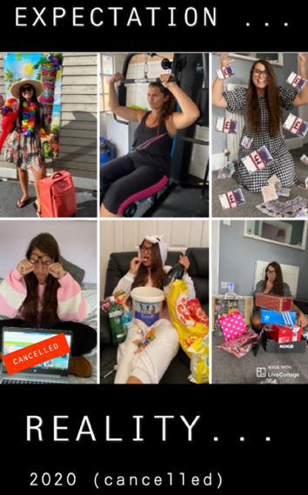

Thanks also to Tracy and Becca for their great entries.

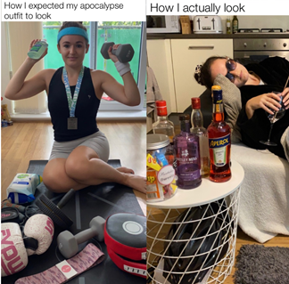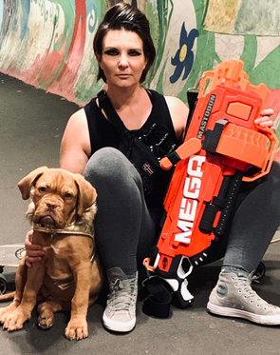

I know lots of you have enjoyed the competitions and they will continue, albeit monthly rather than weekly in future.

The next BC meeting will be on Friday 4 September so there will be no update on Tuesday.

Enjoy the long weekend!

**BC Contacts**

* + - Alex Hughes         07748 857114
    - Karen Genuardi    07801 523186
    - Ian Gill                   07782 248216
    - Vince Bixby           07725 900367
    - Claire Pitman        07956 862824
    - Craig Turner          07946 629052
    - Adrian Bennett      07817 894781
    - Alok Suthar           07877 350839
    - Dan Byrne             07503 475521

|  |  |
| --- | --- |
| Ian Gill **Partner, Patent & Trade Mark Attorney** | |
| **T:** +44 (0) 20 7440 6841 **E:** [isg@aathornton.com](mailto:isg@aathornton.com) | [Linkedin](https://www.linkedin.com/company/aathornton)[Twitter](https://twitter.com/AAThorntonCo) |

|  |  |  |
| --- | --- | --- |
|  | AA Thornton |  |
|  |  |
| **AA Thornton**  15 Old Bailey, London, EC4M 7EF   **T:**+44 (0) 20 7405 4044    **F:** +44 (0) 20 7405 3850    **W:**  [aathornton.com](http://www.aathornton.com) | | |
| Please note the change in our address to 15 Old Bailey, EC4M 7EF. COVID-19 - At AA Thornton we are able to continue to provide an uninterrupted, high-quality service to our clients. Please click [here](http://www.aathornton.com/covid-19/) for our latest update. | | |

