Hi
It was good to see so many people!
Here is a link to the video for those who missed it and a couple of photos.
https://youtu.be/WSjBgtUC3O0
Well done Tracy for getting closest with your guess and winning the HUGE cash prize!
Enjoy your weekend.
Ian
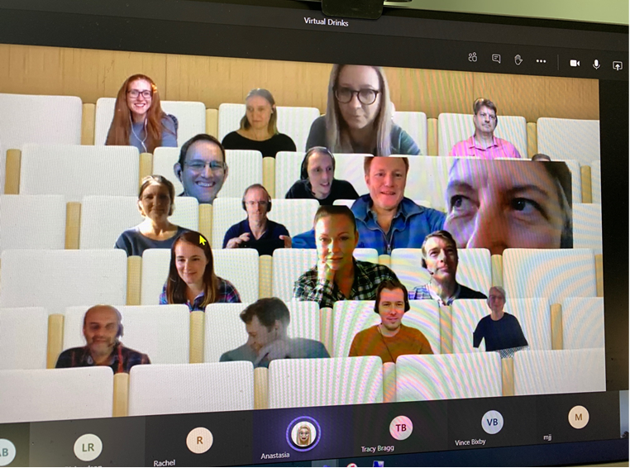

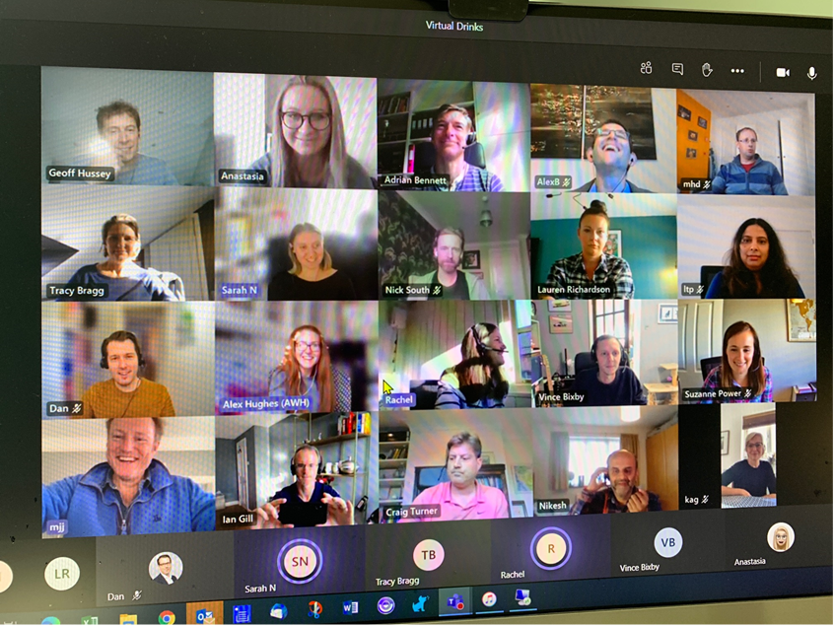

Ian Gill
Partner, Patent & Trade Mark Attorney
T: +44 (0) 20 7440 6841
E: isg@aathornton.com
AA THORNTON
AA Thornton 15 Old Bailey, London, EC4M 7EF
T: +44 (0) 20 7405 4044 F: +44 (0) 20 7405 3580 W: aathornton.com
Please note the change in our address to 15 Old Bailey, EC4M 7EF. COVID-19 - At AA Thornton we are able to continue to provide an uninterrupted, high-quality service to our clients. Please click here for our latest update.

