

The ***NOW That’s what I call a BD update!*** is back with its first home-working edition of COVID-19. Alfred refuses to take off his lab coat whilst wfh, and although without nice window view he had before, doesn’t have to worry about leaving his goldish to go to work anymore.

**Please treat all the sections below as confidential and do not share outside the firm. If you would like more information, contact the relevant fee-earner. All of the information should already be, or will be finding its way into the CRM shortly at the responsibility of the relevant FE.**

**PLEASE NOTE: the BD newsletter will now run bi-weekly.**

1. **Any new work from existing client**

**RSH -** In the last week we have had more UK trade mark filing instructions for pharmaceuticals marks from [Zentiva](https://www.zentiva.com/), suggesting a ramping up of such national filings ahead of Brexit, where previously they would have covered the UK with an EU mark from the Czech Republic.

**ISG -** [Twinings/Ovo](https://www.twinings.co.uk/hot-chocolate-coffee-other-drinks) have structured the way the organise IP and this is leading to a reasonable number of new enquiries. Our new clients [Acetum](https://www.acetum.it/en/) (part of ABF) and [Silver Cross](https://www.silvercrossbaby.com/) prams are now on our records and sending work.

**MJJ** - We are being considered for IP strategy work for [Cambridge Quantum Computing Limited](https://cambridgequantum.com/)

* We just received some new filings for [HP](https://www.hpe.com/us/en/home.html)

1. **Any new client work**

**ISG -** We are working for [David Lowe and Company Limited](https://www.davidlowe.ie/) (Tony Stephens referral) and [Rohen Limited](https://www.youtube.com/watch?v=zyhHBIXlB5o) (website enquiry) in relation to IP disputes

**MJJ** - We just filed our first application this week for Japanese client [Adamant Namiki Precision Jewel Co., Ltd.](https://www.ad-na.com/en/)

* We have been told to expect some new cases and a transfer of cases for [Veracode, Inc.](https://www.veracode.com/)

1. **Any BD initiatives/conversations you want to share with your colleagues**

**SMN -**  Sarah wrote an article online infringements, directed primarily at copycats with the intention of using it to engage with a prospective company. Sarah shared this with her contact, who in turn shared the article to her own network online! Great use of targeted content Sarah!

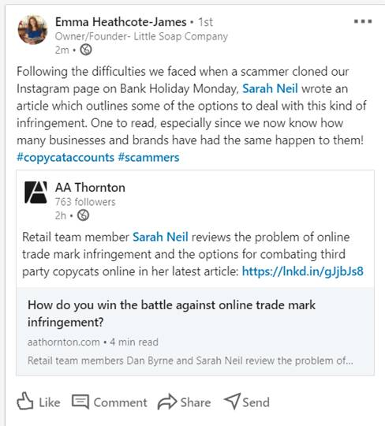

**ISG -** A second article in the series I am creating about decisions to the Appointed Person in the UK will be published by IPKat shortly and then be available for republication on our website – thanks to Sarah N for reviewing that. I am working on a seminar to take place at FICPI’s digital forum in November – the seminar relates to IP valuation.

**MJJ -**  I reached out to some IP Federation members and some existing clients about the UKIPO’s new consultation on AI and IP

* I have suggested that the UKIPO considers a ‘case study’ on our client [Servomex](https://www.servomex.com/), to highlight some good aspects of UKIPO customer service and to highlight how we exploit some acceleration options at the UKIPO to achieve fast grant and downstream cost savings and fast access to the Patent Box (reduced corporation tax for revenues derived from patented technology).
* I used the recent press speculation about an increase in corporation tax rate as an excuse to remind some contacts about the Patent Box tax savings, which allow UK companies to pay 10% instead of 19% corporation tax on revenues from patented technology
* I have offered to give a webinar to the IP Owners Association on patentability of computer simulation (following the upcoming decision in EPO case G1/19). This is to target US companies and highlight our expertise in patenting computer simulation – a technology used in many different industries. We know IPO is interested in G1/19
* I have agreed to give a webinar to IP firm [Spruson & Ferguson](https://www.spruson.com/) on the same subject.
* I suggested that the EPO put together a discussion group for case G1/19, and the EPO Patent Law Director replied that we should do this after the decision to agree how guidance from G1/19 should be implemented. The idea was to get us an invitation to a conversation that will include various industry people.
* We have reached out to IBM and HP contacts who are both considering us for some new work.

**AVO** – We are pitching for collaborative work with [Everys Solicitors](https://www.everys.co.uk/) (Anastasia’s former employer) for [Crediton Dairy](https://www.creditondairy.co.uk/). A pitch document has been submitted and we await info on next rounds.

**GDH -** I have an opportunity to send the head of IP at [Smith & Nephew](https://www.smith-nephew.com/uk/) an email about us – He is US based Mark Gorman and he was on the other side of my ConvaTec litigation. I sent him a linked-in contact request a few weeks ago along with a big sales job of a message about how great we would be for S&N. He finally responded sending me his S&N email address and asking me to send him some info. Geoff sent a tailored response by the direct email.

1. **Any referral to highlight**

**MJJ -** The case for Adamant Namiki Precision Jewel Co., Ltd. (see 2 above) followed a recommendation from our friends at Prinz & Partner

* We were recommended for the Veracode work (see 2 above)

1. **“The most interesting or unusual question I was asked this week”**

**MJJ -** “Have we finished the race yet?”

1. **Anything else you want to share with colleagues**

**MLP** – Marianne spoke at the [CIPA congress on 17 September as part of the IP Ability Committee](I’m%20speaking%20at%20CIPA%20congress%20tomorrow:%20https:/cipa.org.uk/whats-on/events/cipa-congress-access-all/).

**Marketing & BD team:**

* **Chambers Submission deadline – Nov/ Dec 2020 –** with only 100 days left until Christmas (on Wednesday), this is our cue to start thinking about highlights for chambers submissions! Whilst we don’t have a date yet for submission it is likely to be in late Nov/ Dec.

**Please begin to add your thoughts on possible highlights into the spreadsheets attached.**

* **Content for the website**:

Items in Editorial Schedule (upcoming): 2 items upcoming

**September** - TO BE POSTED ON MONDAY - AMTB – BioScience Today repost

**October** - ISG – article ‘decisions to the Appointed Person in the UK’ FICPI (October)

**November** - 0

We should be aiming to post a minimum of 2 articles per month. I will be creating a new physical editorial schedule for everyone to access and ‘book’ a slot* for upcoming articles so that we can ensure regular content. *This is not to discourage other adhoc / last minute articles such as legal updates / hot topics etc!

Content allows us to be found on Google (by generating organic SEO) by clients, potential clients, future employees, whether it is hosted on our website or LinkedIn or Twitter or Lexology. It is content that differentiates us from other firms and makes people pick up the phone. It is content that shows “I know what I am talking about and that’s why you should work with me”. ☺. Please do not underestimate the power of an article (however short it might be) to pick up new work! If you have anything in pipeline, or would like some ideas please let me know.

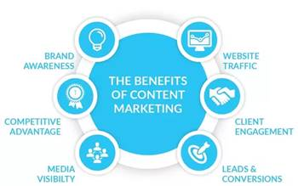

* **CRM:**

**Items added to the CRM in the last 4 weeks:** 3 items

As a reminder the CRM is there to help you find lots of information about contacts and clients easily. It is searchable, whereas for example those newsletters are not. But it is only as good as the amount of info we put in so please can you *all* do your bit by logging your calls/conversations/emails etc so we all know who is speaking to whom and about what ☺. If you have forgotten how to use the CRM, or what you should log in there, just let us know and we can go through this with you.

* **Marketing surgery:** Please drop me an email if you are keen to schedule in some time to complete a training on a LinkedIn / Twitter or perhaps would like me to do a MOT on your online profiles or for us to sit together and come up with a game plan session for your online presence. You’ll remember I last spoke about how, in a recent session with Marianne, after a quick glance of her online presence, and a quick [google of her name](https://www.google.com/search?q=Marianne+Privett&rlz=1C1GCEU_enGB819GB819&oq=marianne&aqs=chrome.0.69i59l2j69i57j0l2j69i60l3.1351j0j4&sourceid=chrome&ie=UTF-8) showed she dominates the entire front page with AAT activities!! Now whilst I appreciate she is lucky that she doesn’t seem to share this name online with many others, a quick scroll positively highlights how doing lots of different things including having an up to date LinkedIn, us tagging her in pictures online, her writing articles, tweeting, and attending various events means that every single one of the results on page 1 of google are all hers! Hurray!
* **Capacity:** Please bearwith me as you will be aware that I am now working on my own. If you do need anything please drop me an email and I will get back to you as soon as possible. I keep my calendar up to date and you can find me online usually from 8am. If you have a quick question that would be better served over a quick chat, feel free to video-call on Teams or call me on my mobile / direct line (ext 838)

Many thanks,

Alex

|  |  |
| --- | --- |
| Alexandra Hughes **Marketing / Business Services Executive** | |
| **T:** 07748857114 **E:** [awh@aathornton.com](mailto:awh@aathornton.com) | [Linkedin](https://www.linkedin.com/company/aathornton)[Twitter](https://twitter.com/AAThorntonCo) |

|  |  |  |
| --- | --- | --- |
|  | AA Thornton |  |
|  |  |
| **AA Thornton**  15 Old Bailey, London, EC4M 7EF   **T:**+44 (0) 20 7405 4044    **F:** +44 (0) 20 7405 3580    **W:**  [aathornton.com](http://www.aathornton.com) | | |
| Please note the change in our address to 15 Old Bailey, EC4M 7EF. COVID-19 - At AA Thornton we are able to continue to provide an uninterrupted, high-quality service to our clients. Please click [here](http://www.aathornton.com/covid-19/) for our latest update. | | |

