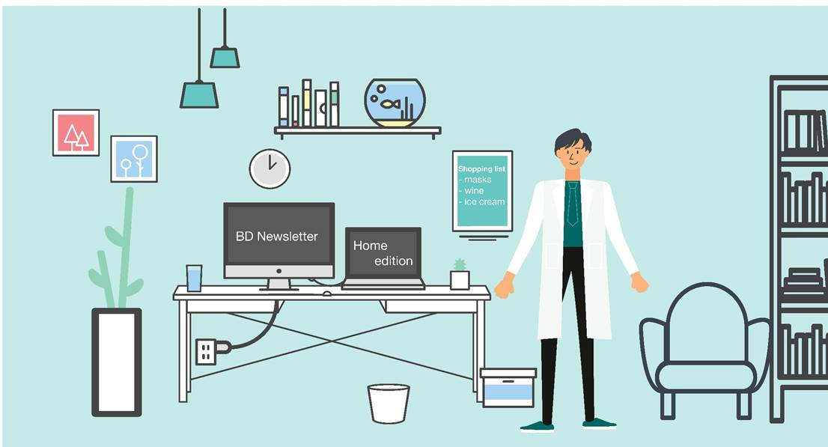

The ***NOW That’s what I call a BD update!*** is back with its first home-working edition of COVID-19. Alfred refuses to take off his lab coat whilst wfh, and although without nice window view he had before, doesn’t have to worry about leaving his goldish to go to work anymore.

**Please treat all the sections below as confidential and do not share outside the firm. If you would like more information, contact the relevant fee-earner. All of the information should already be, or will be finding its way into the CRM shortly at the responsibility of the relevant FE.**

**PLEASE NOTE: the BD newsletter will now run bi-weekly, with the next instalment (due to A/L) appearing on 18th September!**

1. **Any new work from existing client**

**RSH -** We have started to see a lot more UK focussed trade mark work from direct pharma client Zentiva of the Czech Republic, which hopefully will only increase with the effects of Brexit. We have conducted several UK TM searches for them in the last couple of weeks, with instructions for 5 more just in. Also we have just filed our first new UK TM applications for them, for 3 new marks.

1. **Any new client work**

**RSH -** There is potential for some significant new TM work from South African firm Moore Attorneys <https://www.mooreattorneys.com>. We have not worked with this firm (yet), and I met their Shane Moore and Tyrone Walker last October, as they were visiting a number of London firms and had asked to see us. Last week, Shane Moore requested cost estimates for their client CAPITAL WORKS – [www.capitalworksip.com](http://www.capitalworksip.com), who are potentially looking at protection of up to 10 trade marks in 40+ jurisdictions. Sarah N very kindly pulled the information together within a tight turnaround time and we received the following encouraging feedback from Shane:

You have a great team at AA Thornton, and we received detailed information, advice and costings within a few days. Thank you ! I hope we are able to work with you and your team on this project in the near future.

From Soei Patent & Law firm, of Japan, we have received a further indication that they would like us to take over some TM cases, initially for renewals but with us to become IPO address for service, for a substantial pharma client of theirs, HISAMITSU PHARMACEUTICAL CO., INC. They have some TM registrations up for renewal later this year, which are currently with Maucher Jenkins, so these will hopefully come our way soon.

1. **Any BD initiatives/conversations you want to share with your colleagues**

**SGG** - I had a meeting with [HAGS-SMP Limited](https://www.hags.com/en-us/play/playground-equipment) earlier in the week (a company that make outdoor play equipment).  They are looking to enter into a manufacturing agreement with “The Great Outdoor Gym Company” but firstly they want us to give an opinion on the robustness of the patents held by that company.  Referred to me from Ian.

1. **Any referral to highlight**
2. **“The most interesting or unusual question I was asked this week”**

**RSH -** I have been asked to carry out a search for a trade mark for knives, (I hope) for culinary use, but the description of goods to be searched is:

*CLASS 008

knives comprising a radio frequency transmitting device

*CLASS 009

control software for locating and using knives; hardware for reading and collecting data from knives

Why would anyone need that!?

1. **Anything else you want to share with colleagues**

**Marketing & BD team:**

* **Content for the website**: Content that allows us to be found on Google by clients, potential clients, future employees, whether it is hosted on our website or LinkedIn or Twitter or Lexology. It is content that differentiates us from other firms and makes people pick up the phone. It is content that shows “I know what I am talking about and that’s why you should work with me”. ☺. Please do not underestimate the power of an article (however short it might be) to pick up new work! If you have anything in pipeline, or would like some ideas please let me know.
* **CRM:** Our records show that, unfortunately, engagement with the CRM is still very low! As a reminder the CRM is there to help you find lots of information about contacts and clients easily. It is searchable, whereas for example those newsletters are not. But it is only as good as the amount of info we put in so please can you *all* do your bit by logging your calls/conversations/emails etc so we all know who is speaking to whom and about what ☺. If you have forgotten how to use the CRM, or what you should log in there, just let us know and we can go through this with you.
* **Marketing surgery:** Please drop me an email if you are keen to schedule in some time to complete a training on a LinkedIn / Twitter or perhaps would like me to do a MOT on your online profiles or for us to sit together and come up with a game plan session for your online presence. You’ll remember I last spoke about how, in a recent session with Marianne, after a quick glance of her online presence, and a quick [google of her name](https://www.google.com/search?q=Marianne+Privett&rlz=1C1GCEU_enGB819GB819&oq=marianne&aqs=chrome.0.69i59l2j69i57j0l2j69i60l3.1351j0j4&sourceid=chrome&ie=UTF-8) showed she dominates the entire front page with AAT activities!! Now whilst I appreciate she is lucky that she doesn’t seem to share this name online with many others, a quick scroll positively highlights how doing lots of different things including having an up to date LinkedIn, us tagging her in pictures online, her writing articles, tweeting, and attending various events means that every single one of the results on page 1 of google are all hers! Hurray!
* **Capacity:** Please bearwith me as you will be aware that I am now working on my own. If you do need anything please drop me an email and I will get back to you as soon as possible. I keep my calendar up to date and you can find me online usually from 8am. If you have a quick question that would be better served over a quick chat, feel free to video-call on Teams or call me on my mobile!
* **Upcoming Leave –** I am off for a week from 7th September following what will be my 30th birthday on Sunday 6th! I’m celebrating/commiserating each decade with three weeks of celebrations, despite ‘Rona (my affectionate name for Coronavirus) trying to steal the spotlight. I’m starting this Saturday with a rooftop brunch which has been Corona-fied beyond the standard social distancing… at the last minute they’ve now banned music and dancing… !!!, oh and it’s due to rain! If we all cross our fingers for another impromptu heatwave tomorrow perhaps the August BH won’t be a total washout! Enjoy your long weekends all!

Many thanks,

Alex

|  |  |
| --- | --- |
| Alexandra Hughes **Marketing / Business Services Executive** | |
| **T:** 07748857114 **E:** [awh@aathornton.com](mailto:awh@aathornton.com) | [Linkedin](https://www.linkedin.com/company/aathornton)[Twitter](https://twitter.com/AAThorntonCo) |

|  |  |  |
| --- | --- | --- |
|  | AA Thornton |  |
|  |  |
| **AA Thornton**  15 Old Bailey, London, EC4M 7EF   **T:**+44 (0) 20 7405 4044    **F:** +44 (0) 20 7405 3850    **W:**  [aathornton.com](http://www.aathornton.com) | | |
| Please note the change in our address to 15 Old Bailey, EC4M 7EF. COVID-19 - At AA Thornton we are able to continue to provide an uninterrupted, high-quality service to our clients. Please click [here](http://www.aathornton.com/covid-19/) for our latest update. | | |