Hi all,

Thank you to all the Partners that took part in **Geoff’s forfeit for the Partners** and all of the people that participated in taking screen shots and photos!

Below are some of the photos:

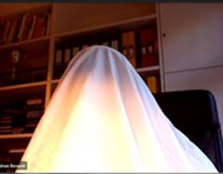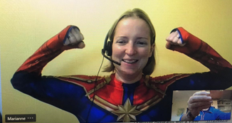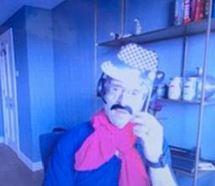

The Social Committee have collectively agreed on a winner!

………….. & the **Winne**r is  ……………\***drum rolls**\*

**Marianne**



Who used the following song titles during the meeting:  *Sorry (Justin Bieber), Why? (Carly Simon), Cool (Gwen Stefani), What’s Going On? (4 non-blondes), 5 Minutes (The Stranglers), A Little Less Conversation (Elvis), People Are Strange (The Doors), Respect (Aretha Franklin) also Natasha Dance (Chris de Burgh) and Craig (Stephen Lynch)*

**Well done!!**

A member of the Social Committee will contact you regarding your prize!

Thanks,

Mal (on behalf of the Social Committee)

|  |  |
| --- | --- |
| Malika Davis-Garvis **Principal Trade Mark Secretary** | |
| **E:** [mrd@aathornton.com](mailto:mrd@aathornton.com) | [Linkedin](https://www.linkedin.com/company/aathornton)[Twitter](https://twitter.com/AAThorntonCo) |

|  |  |  |
| --- | --- | --- |
|  | AA Thornton |  |
|  |  |
| **AA Thornton**  15 Old Bailey, London, EC4M 7EF   **T:**+44 (0) 20 7405 4044    **F:** +44 (0) 20 7405 3580    **W:**  [aathornton.com](http://www.aathornton.com) | | |
| Please note the change in our address to 15 Old Bailey, EC4M 7EF. COVID-19 - At AA Thornton we are able to continue to provide an uninterrupted, high-quality service to our clients. Please click [here](http://www.aathornton.com/covid-19/) for our latest update. | | |

