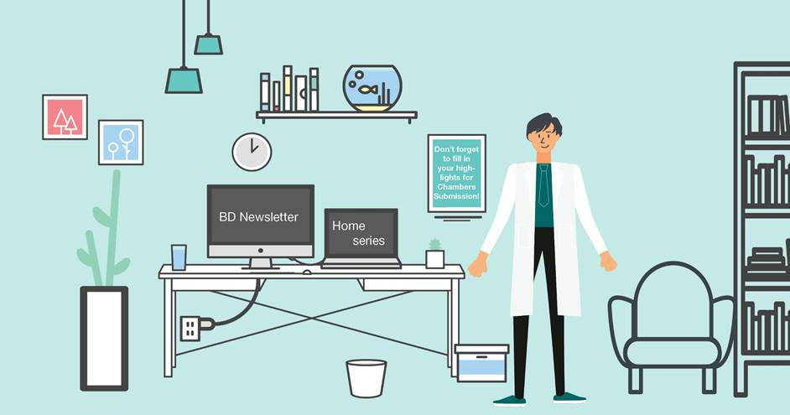

The ***NOW That’s what I call a BD update!***

**Please treat all the sections below as confidential and do not share outside the firm. If you would like more information, contact the relevant fee-earner. All of the information should already be, or will be finding its way into the CRM shortly at the responsibility of the relevant FE.**

**PLEASE NOTE: the BD newsletter will now run bi-weekly.**

1. **Any new work from existing client**
2. **Any new client work**

**ISG**

* We have been approached via Tony Stephens at Stephens and Associates to conduct due diligence on a small trade mark portfolio that is being bought out of administration – that mark is [PETER PILOTTO](https://www.harpersbazaar.com/uk/fashion/fashion-news/a31132198/peter-pilotto-break/) who some may recognise as the name of the person who designed Princess Eugenie wedding dress.
* We have been approached by a small but rapidly growing home delivery service to assess their IP. This was a referral from another recent new client, [Silver Cross](https://www.silvercrossbaby.com/).
* We have been asked to help [British Nutrition Foundation](https://www.nutrition.org.uk/) with a rebrand – this was a referral from an ABF lawyer.

**ARB**

* New UK based client Cryogenix Ltd have instructed use in respect of drafting a patent application for their new cooling equipment for medical treatments.  They were recommended to us.

1. **Any BD initiatives/conversations you want to share with your colleagues**

**ISG**

* Geoff and I spoke with [AWA](https://www.awa.com/) about taking on some of their new UK cloned rights following the end of the transition period and we are working on a proposal for them.
* Building on Geoff/Marianne/Lawrence’s work in getting some patent work from Estee Lauder, I have approached them asking for trade mark work based partly on our Legal 500 ranking.

**ARB/GDH/AWH**

* We have signed up to use an online research platform which may help us identify start-ups in need of IP service providers. We will be putting together a project group to make the most of our subscription to the platform over the next 12 months.

1. **Any referral to highlight**

1. **“The most interesting or unusual question I was asked this week”**
2. **Anything else you want to share with colleagues**

**Marketing & BD team:**

* **Chambers Submission deadline – Nov/ Dec 2020 –** Please begin to add your thoughts on possible highlights into the spreadsheets attached.
* **CRM:**

**Items added to the CRM in the last 4 weeks: 5 items**

All BD calls/conversations/emails/ LinkedIn convos should be captured in the CRM so that we can track our leads. My email with hints and tips for using the CRM (including using the Secretarial Task button for CRM) is attached.

* **Content for the website**:

Items in Editorial Schedule (upcoming): 0 items upcoming

**November** - 0

We should be aiming to post a minimum of 2 articles per month. I will be creating a new physical editorial schedule for everyone to access and ‘book’ a slot* for upcoming articles so that we can ensure regular content. *This is not to discourage other adhoc / last minute articles such as legal updates / hot topics etc!

Content allows us to be found on Google (by generating organic SEO) by clients, potential clients, future employees, whether it is hosted on our website or LinkedIn or Twitter or Lexology. It is content that differentiates us from other firms and makes people pick up the phone. It is content that shows “I know what I am talking about and that’s why you should work with me”. ☺. Please do not underestimate the power of an article (however short it might be) to pick up new work! If you have anything in pipeline, or would like some ideas please let me know.

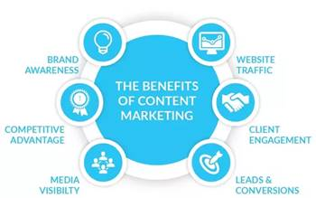

* **Capacity:** Please bearwith me as you will be aware that I am now working on my own. If you do need anything please drop me an email and I will get back to you as soon as possible. I keep my calendar up to date and you can find me online usually from 8am. If you have a quick question that would be better served over a quick chat, feel free to video-call on Teams or call me on my mobile / direct line (ext 838)

Many thanks,

Alex

|  |  |
| --- | --- |
| Alexandra Hughes **Marketing / Business Services Executive** | |
| **T:** 07748857114 **E:** [awh@aathornton.com](mailto:awh@aathornton.com) | [Linkedin](https://www.linkedin.com/company/aathornton)[Twitter](https://twitter.com/AAThorntonCo) |

|  |  |  |
| --- | --- | --- |
|  | AA Thornton |  |
|  |  |
| **AA Thornton**  15 Old Bailey, London, EC4M 7EF   **T:**+44 (0) 20 7405 4044    **F:** +44 (0) 20 7405 3580    **W:**  [aathornton.com](http://www.aathornton.com) | | |
| Please note the change in our address to 15 Old Bailey, EC4M 7EF. COVID-19 - At AA Thornton we are able to continue to provide an uninterrupted, high-quality service to our clients. Please click [here](http://www.aathornton.com/covid-19/) for our latest update. | | |

