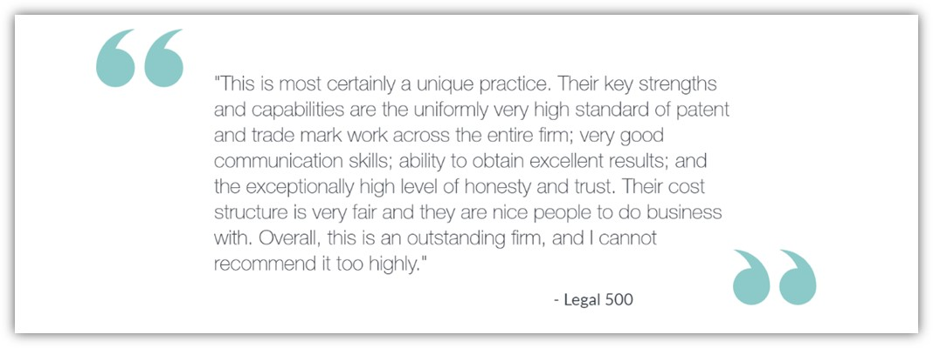

The ***NOW That’s what I call a BD update!***

***It’s late and it’s lean this week!***

**Please treat all the sections below as confidential and do not share outside the firm. If you would like more information, contact the relevant fee-earner. All of the information should already be, or will be finding its way into the CRM shortly at the responsibility of the relevant FE.**

**PLEASE NOTE: the BD newsletter will now run bi-weekly.**

1. **Any new work from existing client**

**GDH/LLK/ MLP -** we recently received three new European patent filings from [Estee Lauder](https://www.esteelauder.co.uk/?gclsrc=aw.ds&&gclid=CjwKCAjwn9v7BRBqEiwAbq1EyzSvmOnPApYRY-pHy7qwZvUduleeHNLviNd_gKSyds--MC2xN1ZoFhoC3MEQAvD_BwE&gclsrc=aw.ds). This is a welcome addition to the original European filing that we received a month or so ago and follows some presentations that Geoff, Marianne and I gave to their NY-based patents team earlier in the year.

1. **Any new client work**

**GDH -** A possible new patent infringement case for [University of Geneva](https://www.unige.ch/en/)

1. **Any BD initiatives/conversations you want to share with your colleagues**

**ARB** – Attended the Entrepreneurship Speed-Networking Event at [Brunel University London](https://www.brunel.ac.uk/)

1. **Any referral to highlight**

1. **“The most interesting or unusual question I was asked this week”**

‘What are you wearing to Thornchella?’

1. **Anything else you want to share with colleagues**

**Marketing & BD team:**

* Legal 500 – Congratulations all on making Tier 1 again from trade marks, remaining a Leading Firm in patents and finally making it into the tables (and not last either!) for litigation wahooo! We were had some really wonderful quotes – go and check them out! <https://www.legal500.com/firms/91828-aa-thornton/93556-london-england/>
* **Chambers Submission deadline – Nov/ Dec 2020 –** with only 100 days left until Christmas (on Wednesday), this is our cue to start thinking about highlights for chambers submissions! Whilst we don’t have a date yet for submission it is likely to be in late Nov/ Dec.

**Please begin to add your thoughts on possible highlights into the spreadsheets attached.**

* **CRM:**

**Items added to the CRM in the last 4 weeks: 2 items**

As a reminder the CRM is there to help you find lots of information about contacts and clients easily. It is searchable, whereas for example those newsletters are not. But it is only as good as the amount of info we put in so please can you *all* do your bit by logging your calls/conversations/emails etc so we all know who is speaking to whom and about what ☺. If you have forgotten how to use the CRM, or what you should log in there, just let us know and we can go through this with you.

* **Content for the website**:

Items in Editorial Schedule (upcoming): 0 items upcoming

**October** - ISG – article ‘decisions to the Appointed Person in the UK’ FICPI (DONE)

**November** - 0

We should be aiming to post a minimum of 2 articles per month. I will be creating a new physical editorial schedule for everyone to access and ‘book’ a slot* for upcoming articles so that we can ensure regular content. *This is not to discourage other adhoc / last minute articles such as legal updates / hot topics etc!

Content allows us to be found on Google (by generating organic SEO) by clients, potential clients, future employees, whether it is hosted on our website or LinkedIn or Twitter or Lexology. It is content that differentiates us from other firms and makes people pick up the phone. It is content that shows “I know what I am talking about and that’s why you should work with me”. ☺. Please do not underestimate the power of an article (however short it might be) to pick up new work! If you have anything in pipeline, or would like some ideas please let me know.



* **Capacity:** Please bearwith me as you will be aware that I am now working on my own. If you do need anything please drop me an email and I will get back to you as soon as possible. I keep my calendar up to date and you can find me online usually from 8am. If you have a quick question that would be better served over a quick chat, feel free to video-call on Teams or call me on my mobile / direct line (ext 838)

Many thanks,

Alex

|  |  |
| --- | --- |
| Alexandra Hughes **Marketing / Business Services Executive** | |
| **T:** 07748857114 **E:** [awh@aathornton.com](mailto:awh@aathornton.com) | [Linkedin](https://www.linkedin.com/company/aathornton)[Twitter](https://twitter.com/AAThorntonCo) |

|  |  |  |
| --- | --- | --- |
|  | AA Thornton |  |
|  |  |
| **AA Thornton**  15 Old Bailey, London, EC4M 7EF   **T:**+44 (0) 20 7405 4044    **F:** +44 (0) 20 7405 3580    **W:**  [aathornton.com](http://www.aathornton.com) | | |
| Please note the change in our address to 15 Old Bailey, EC4M 7EF. COVID-19 - At AA Thornton we are able to continue to provide an uninterrupted, high-quality service to our clients. Please click [here](http://www.aathornton.com/covid-19/) for our latest update. | | |