Hi Everyone,

**Summer Party**

We want to kick off this first Operational Committee update with a shout out to the Social Committee for organising a very successful virtual summer party - lots of fun was had by all and we are pleased to hear the semi-permanent face paint is finally fading away!

BUT…..which member of the Operational Committee peaked a bit too early………..<https://i.giphy.com/media/xT8qBbYBBB1uvWbN7y/giphy.mp4>.?  You know who you are ;)

You can see the photos and video recording as well as stream the official Spotify Thornchella playlist from the intranet - [Thornchella](http://intranet.aat.local/thornchella/_layouts/15/start.aspx#/SitePages/Home.aspx).  The dedicated page can be found under the homeworking tab when hovered over!

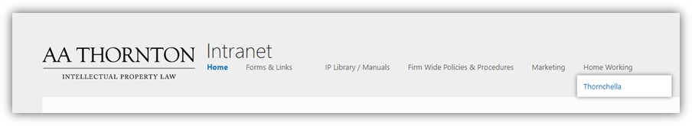

Winners will be announced later this week along with Geoff’s choice of forfeit for the other Partners after his win of **‘Partner Limbo’!**

**World Mental Health Day – 10th October**

It was World Mental Health Day over the weekend.  The event is run annually by the World Health Organization. The theme this year is “[mental health for all](https://www.mentalhealth.org.uk/campaigns/world-mental-health-day)”, and goal is to increase investment in mental health: <https://www.who.int/campaigns/world-mental-health-day/world-mental-health-day-2020>.  There are some resources and links on the intranet and we encourage everyone to stay connected and keep talking – if you haven’t had a chance already, why not drop into a film or book club event or a Wellness Wednesday.

**Remote Working Asset Register**

Please remember to complete a ‘Remote Working Asset Register’ form with Cezanne any time that you request or receive additional AAT equipment. Please see the how to guide attached for more details.

**Roll out of new PC’s at the Data Centre – IT Team will be in touch soon**

As of next week we will start our rollout of new PC’s for everybody at the data centre pushing forward with our plan to reduce both our power draw and also our overall IT footprint in terms of space everything is taking up. We will be in contact with each of you individually to schedule a time where we will move you onto a new desktop in the office. All we need from you is some time uninterrupted to remove your machine from the racks, swap some hardware over and reconfigure. We are putting 1 hour per person initially for this and will adjust accordingly as we progress. We will be in touch to get everybody scheduled in shortly.

**Learning and Development in an Agile Working Environment - Focus Group**

Following on from the request for volunteers to help us consider how we can best support role specific and more general training and learning within a more agile and partially remote working environment, we now have our project team members in place.  Thank you very much to David, Anastasia, Naomi and Caitlan, who will join members of the Operational Committee to develop some solutions for the firm as we navigate our new normal.  The first meeting is being arranged towards the end of October.  If anyone else meant to volunteer and didn’t or would like to join the group, please let us know.  We will keep you updated on progress in due course.

**Free Online Training Resources**

The Institute of Leadership and Management have lots of resources on their website which are free to access.  There are some webinars coming up this week which are aimed at building confidence in running meetings as well as having impactful conversations with colleagues, clients or potential clients remotely:

* Getting the most out of online meetings (13 October)
* Being your best online self (14 October) - Explores crucial online communication skills such as how to really listen and build rapport, and how to make your delivery excellent to get your point across with impact.

There are also lots of recorded podcasts to choose from covering leadership, management but also communication and other topics – so if you are interested in some personal development, then they are definitely worth a look and they are short too!

The link to register free for the podcasts is here: <https://www.institutelm.com/whats-on/podcasts.html>

Many thanks

**The Operational Committee**

|  |  |
| --- | --- |
| Karen Genuardi **Head of People** | |
| **T:** 07801523186 **E:** [kag@aathornton.com](mailto:kag@aathornton.com) | [Linkedin](https://www.linkedin.com/company/aathornton)[Twitter](https://twitter.com/AAThorntonCo) |

|  |  |  |
| --- | --- | --- |
|  | AA Thornton |  |
|  |  |
| **AA Thornton**  15 Old Bailey, London, EC4M 7EF   **T:**+44 (0) 20 7405 4044    **F:** +44 (0) 20 7405 3580    **W:**  [aathornton.com](http://www.aathornton.com) | | |
| Please note the change in our address to 15 Old Bailey, EC4M 7EF. COVID-19 - At AA Thornton we are able to continue to provide an uninterrupted, high-quality service to our clients. Please click [here](http://www.aathornton.com/covid-19/) for our latest update. | | |