Hi all,

I hope that you have enjoyed having a look through the pictures and video from the event last week! If you haven’t already soon them you can find them, and the official Spotify Thornchella playlist, on the intranet in a new tab labelled- [Thornchella](http://intranet.aat.local/thornchella/_layouts/15/start.aspx#/SitePages/Home.aspx).  The dedicated page can be found under the homeworking tab when hovered over!

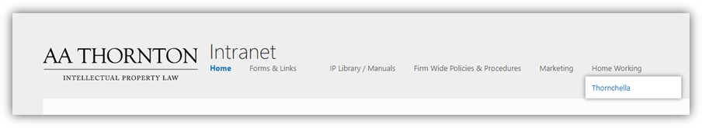

If you have any feedback of the event for the suppliers please - [click here](https://t.sidekickopen78.com/s1t/c/5/f18dQhb0S7kv8cN4_XW5KrjKx2zGCwVW8Jbw_83LQ4pjW8p-_dP3M2f7MW8q5vmn16gGCCf1czyV501?te=W3R5hFj4cm2zwW3KcjHj49PFWfW3Fdy8c41Y220W4rCV-F43WgzYW3Fbt5S4fLGdMF41DszpqGSy1&si=6215786966417408&pi=de7a471e-5c92-409c-ea03-edf12cb897b4).

And now, the part that you have been waiting for….! The announcement of the winners!

**Best dressed – Louise Foster!**

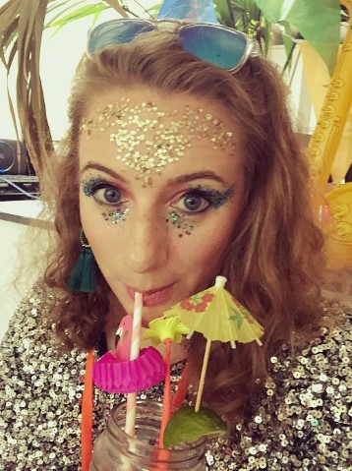

**Best festival selfie – Sarah Darby**

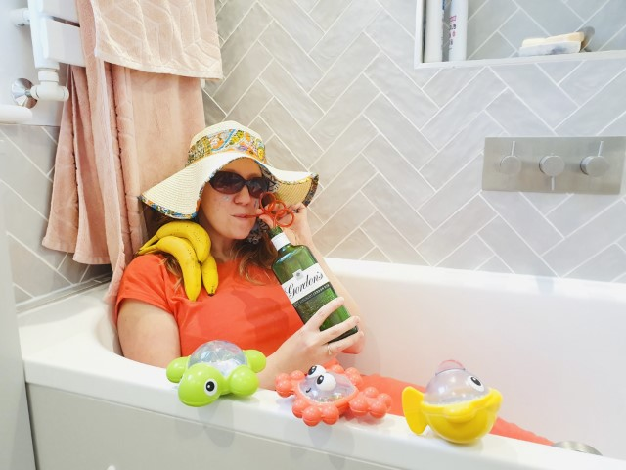

**Best cocktail - Please let us know who you are gin-lover!!**

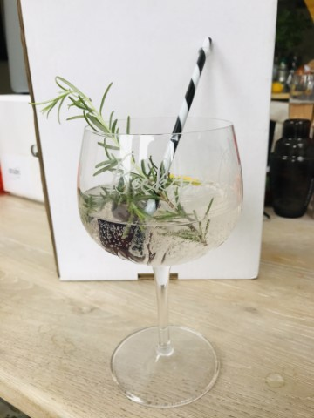

**Best dancer - Sarah Gibson!**

[footage too great to display]

**Bingo Winners:**

First to the one line - **Ian**

First to full house – **Bex**

**Congratulations to all! Each winner will be contacted by a member of SC to arrange your prize!**

**And finally**.. the prize winner of Partner Limbo was Geoff!!! Geoff’s prize (and it’s a pretty great one!!) was to pick a forfeit of choice for the rest of the Partners…. So here goes!

**Geoff’s forfeit for the Partners:**

Partners have to:

* turn up in fancy dress of their choice on an internal Teams/Zoom of their choosing next week; and
* slip in as many song titles as they can into that internal call

The other people on the call have to:

* take a screenshot of the call and circulate it around the firm so we can all judge the fancy dress; and
* note down all the song titles they notice and circulate that at the end of the call so we can all see who managed the most.

**There will be a prize for the person who can supply Geoff / SocCom with both a great screenshot AND the most song titles collected in that call!**

Good luck!

Alex

|  |  |
| --- | --- |
| Alexandra Hughes **Marketing / Business Services Executive** | |
| **T:** 07748857114 **E:** [awh@aathornton.com](mailto:awh@aathornton.com) | [Linkedin](https://www.linkedin.com/company/aathornton)[Twitter](https://twitter.com/AAThorntonCo) |

|  |  |  |
| --- | --- | --- |
|  | AA Thornton |  |
|  |  |
| **AA Thornton**  15 Old Bailey, London, EC4M 7EF   **T:**+44 (0) 20 7405 4044    **F:** +44 (0) 20 7405 3580    **W:**  [aathornton.com](http://www.aathornton.com) | | |
| Please note the change in our address to 15 Old Bailey, EC4M 7EF. COVID-19 - At AA Thornton we are able to continue to provide an uninterrupted, high-quality service to our clients. Please click [here](http://www.aathornton.com/covid-19/) for our latest update. | | |

